# APPENDIX D: TESTING RESULTS

Table 1 Test Cases and Related Figures

|  |  |
| --- | --- |
| **Test Cases (TC)** | **Figures** |
| 1 | 1 |
| 2 | 2, 3 |
| 3 | 4 |
| 4 | 6,8 |
| 5 | 7 |
| 6 | 9 |
| 7 | 10,11 |
| 8 | 12 |
| 11 | 12 |
| 12 | 13,14, 16, 17 |
| 13 | 15, 18 |
| 14 | 19, 20 |
| 15 | 21 – 23 |
| 16 | 24 |
| 17 | 25 |
| 18 | 26, 27 |
| 21 | 33 |
| 22 | 30 – 32 |
| 24 | 34 |
| 25 | 38, 40, 41 |
| 26 | 34, 35, 36 |
| 27 | 42 |
| 29 | 44 |
| 30 | 44 |
| 31 | 45 |
| 32 | 46 |
| 33 | 47 |
| 34 | 48 |
| 35 | 49 |
| 36 | 50 |
| 37 | 51 |
| 38 | 53 - 57 |
|  |  |

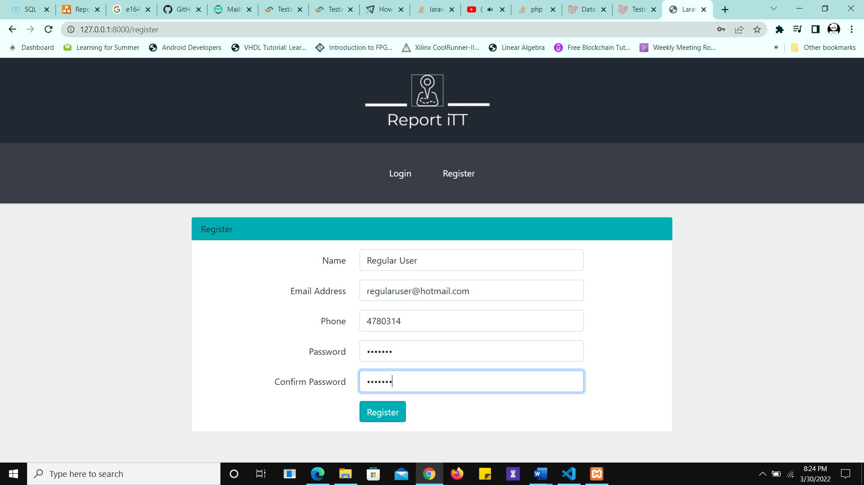

Figure 1 User "Regular User" Registers

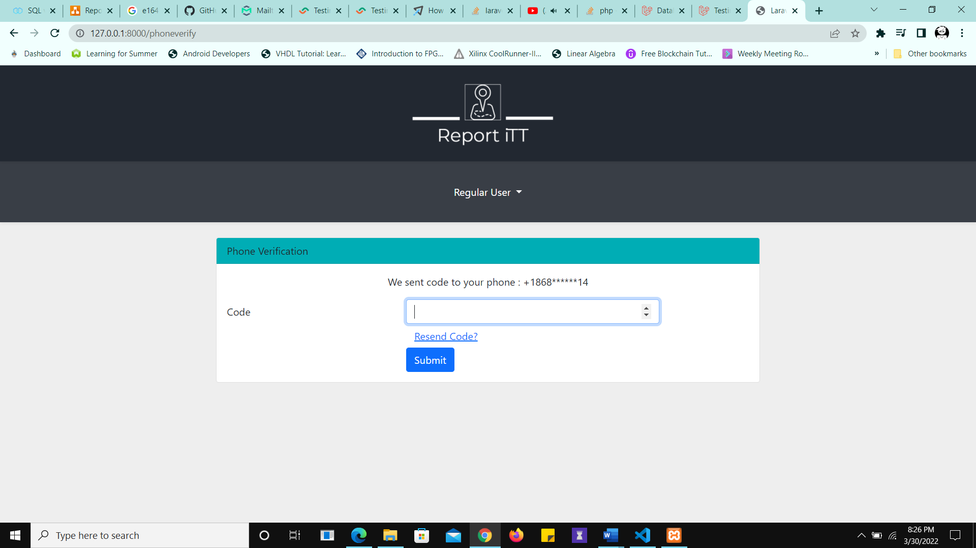

Figure 2 Verification Code Sent

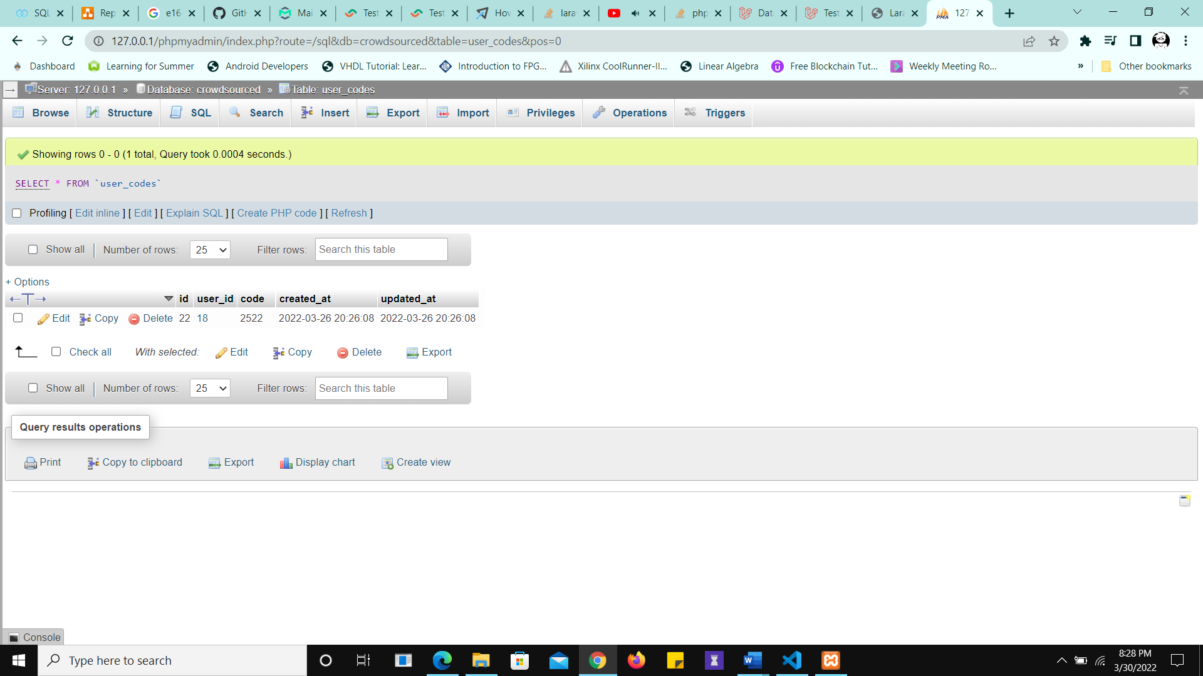

Figure 3 Database Entry Created for the verification code

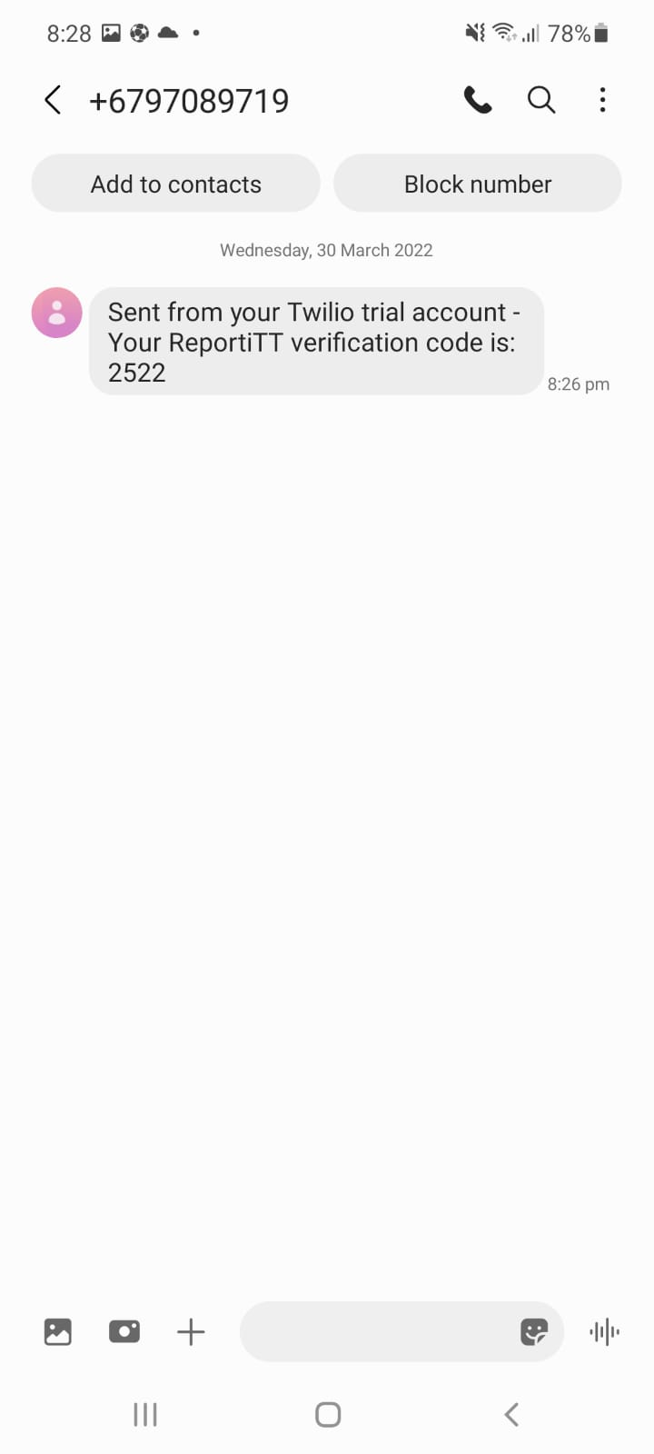

Figure 4 SMS Code Received

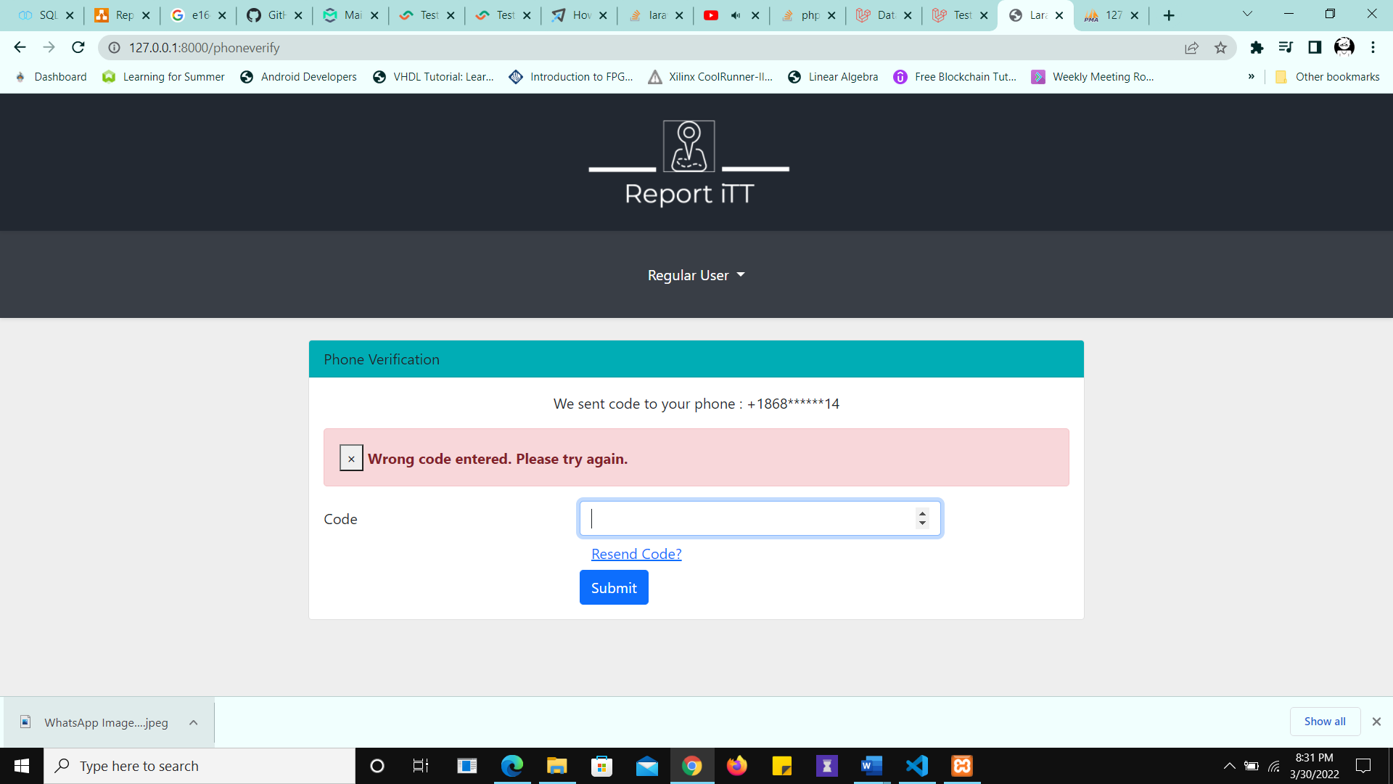

Figure 5 Wrong code entered

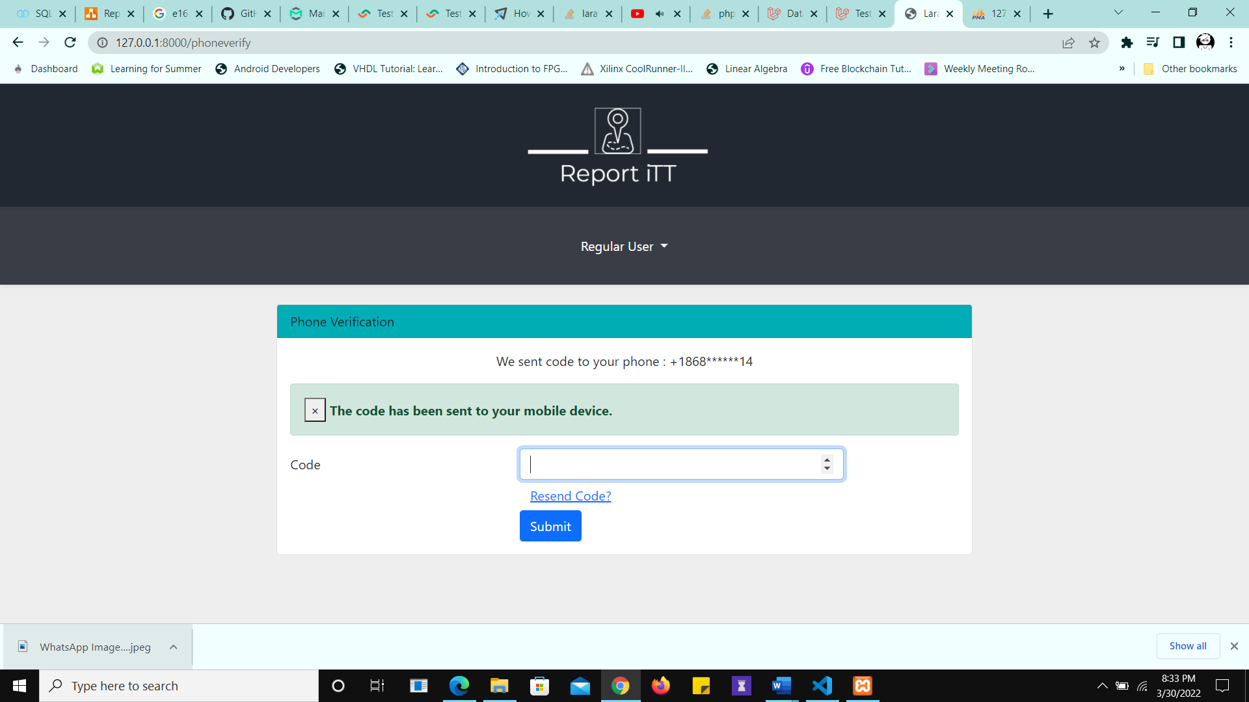

Figure 6 Resend Code

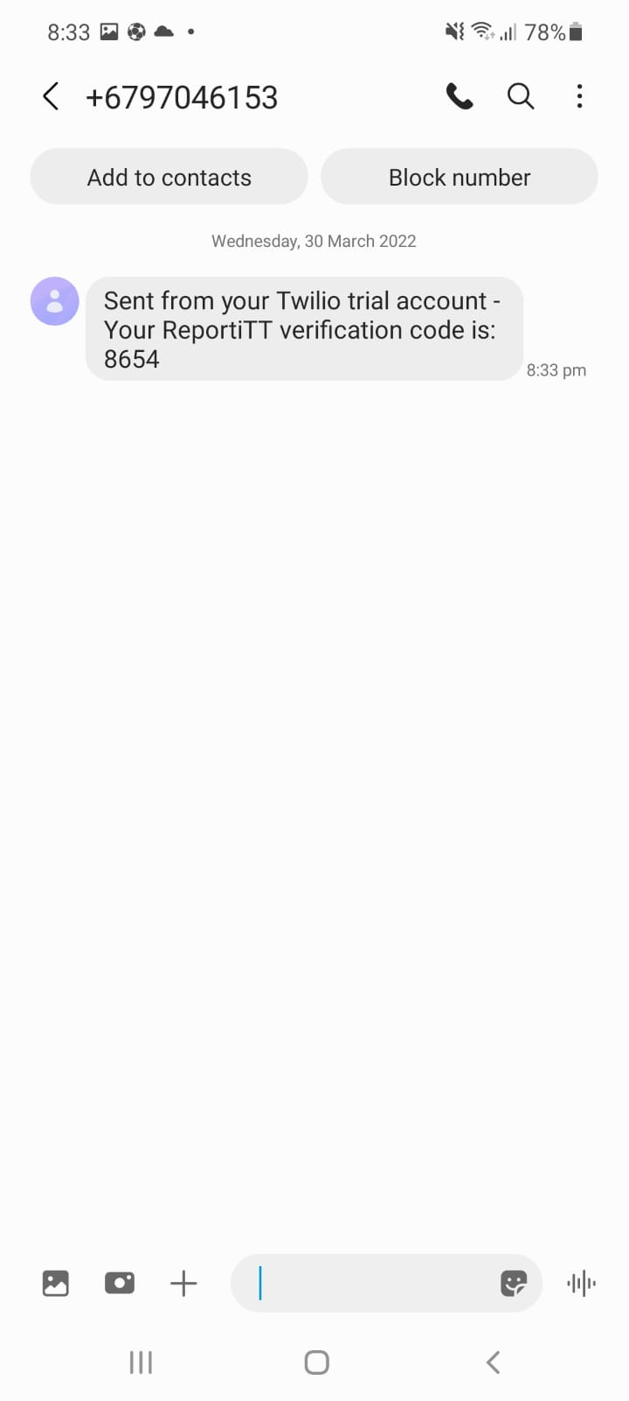

Figure 7 Code Resent after clicking resend code

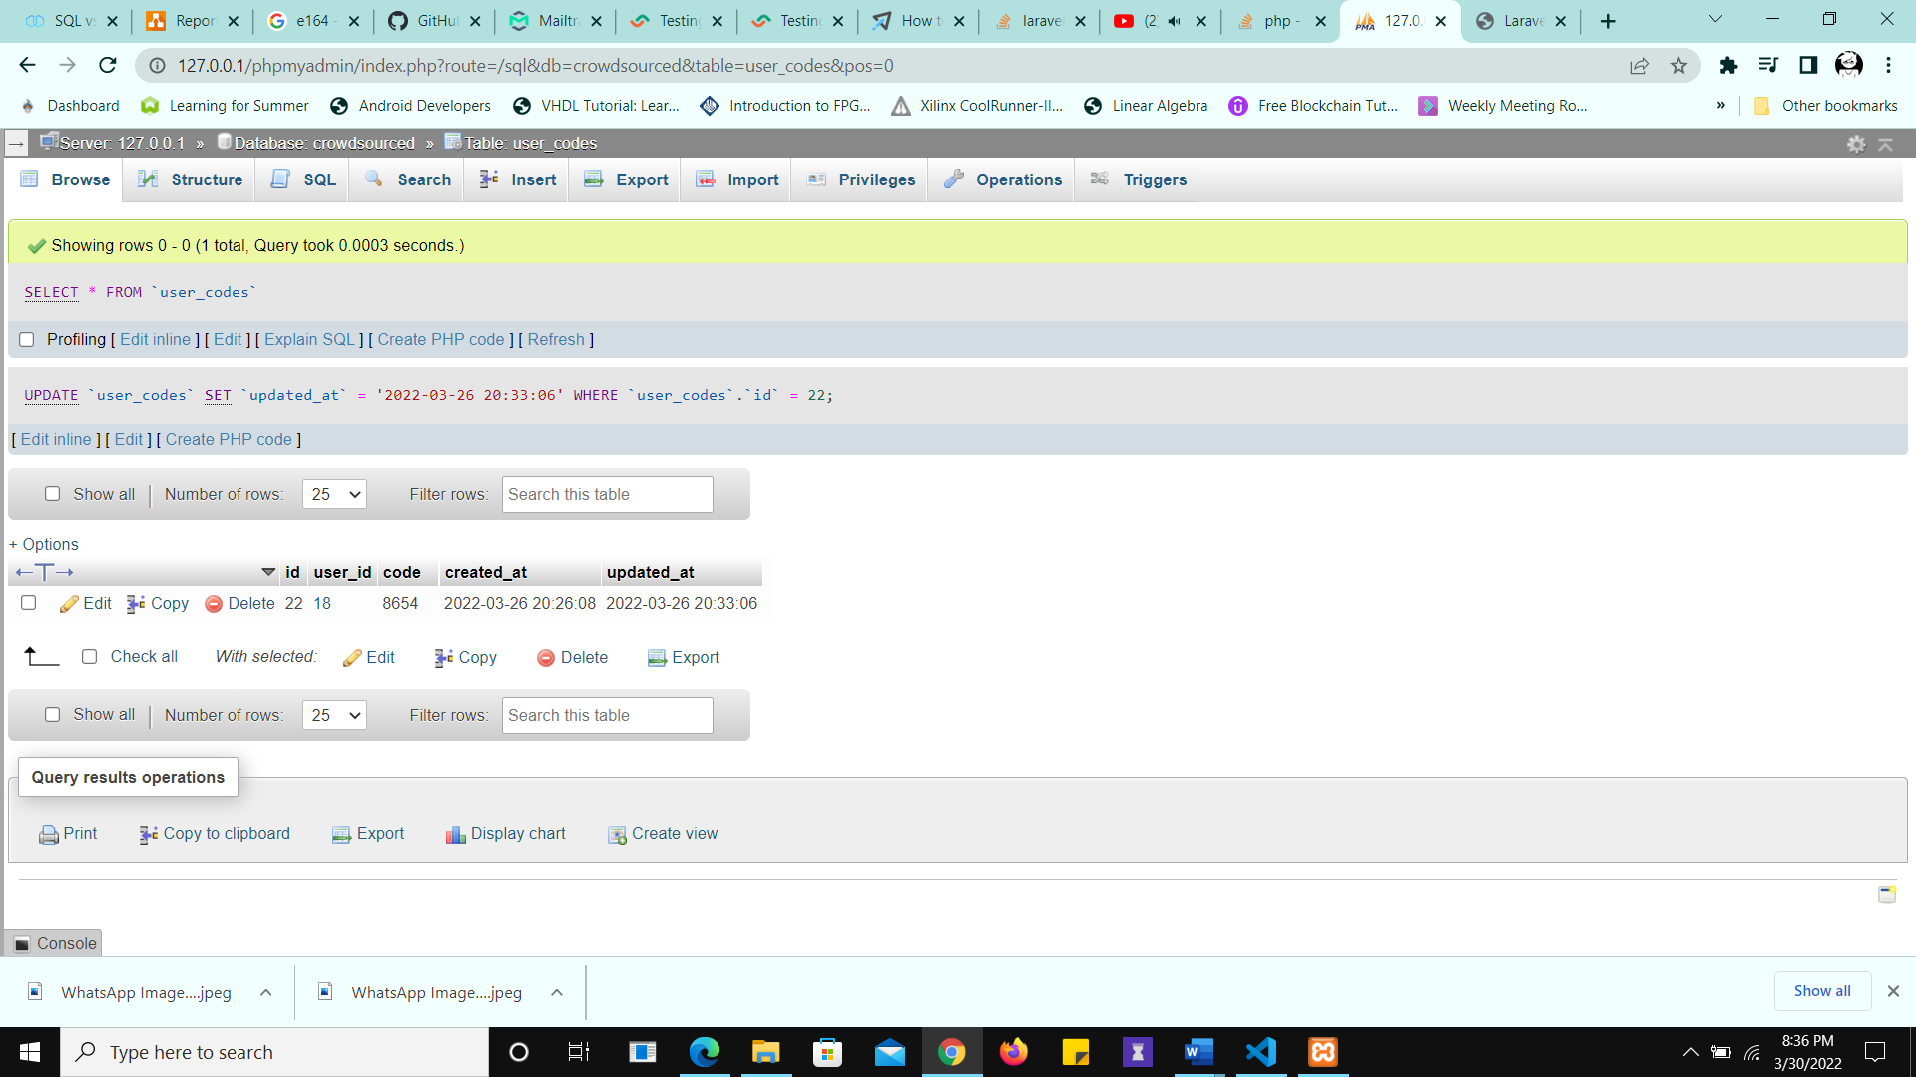

Figure 8 Database Updated with new code when it is resent

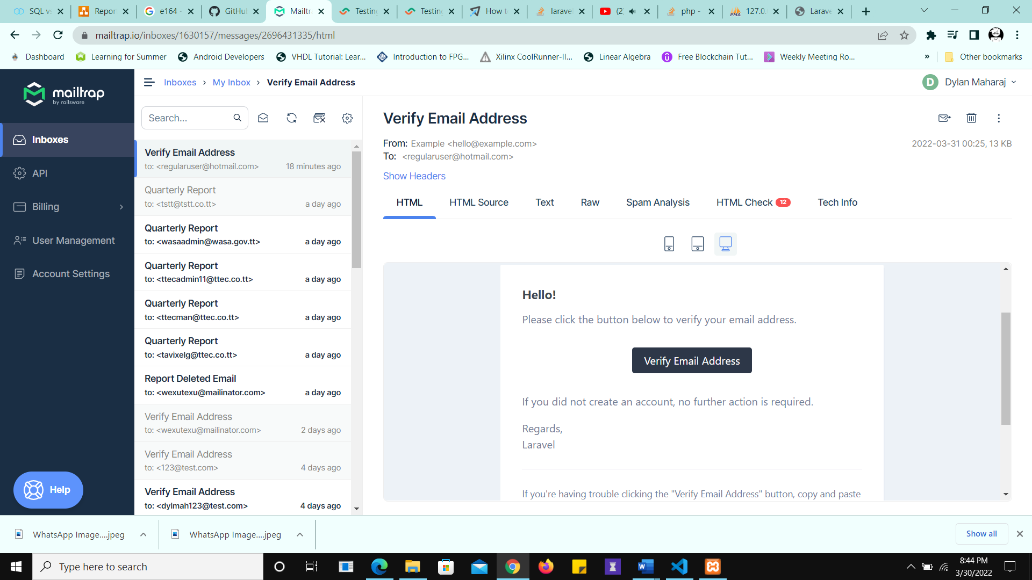

Figure 9 Email verification sent

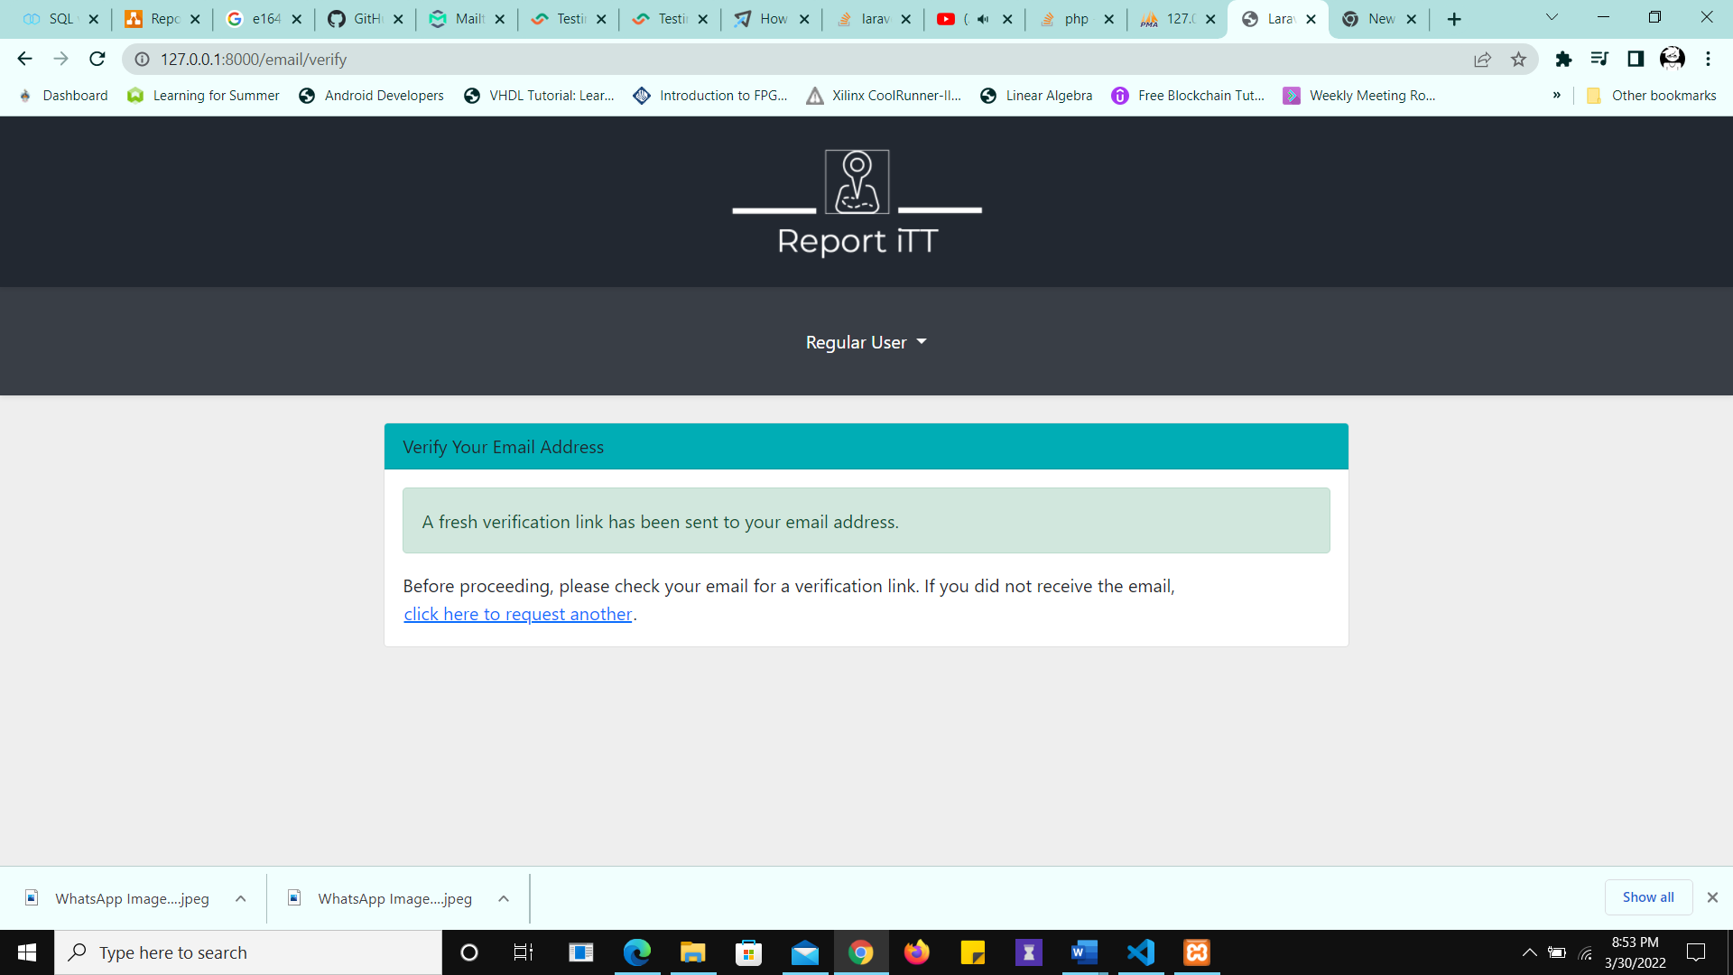

Figure 10 Fresh verification sent

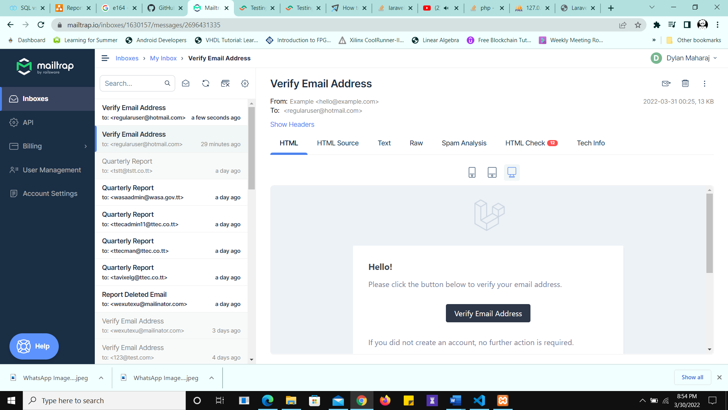

Figure 11 Fresh Verification Received in Mailtrap

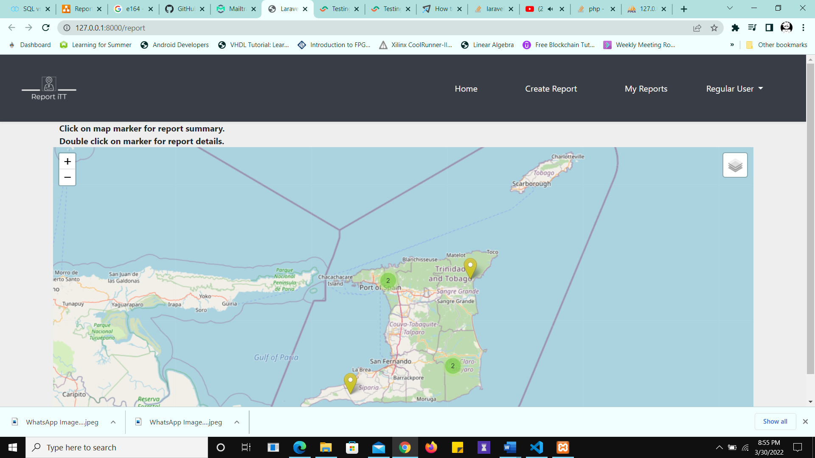

Figure 12 User Directed to the Home Page after successful verification

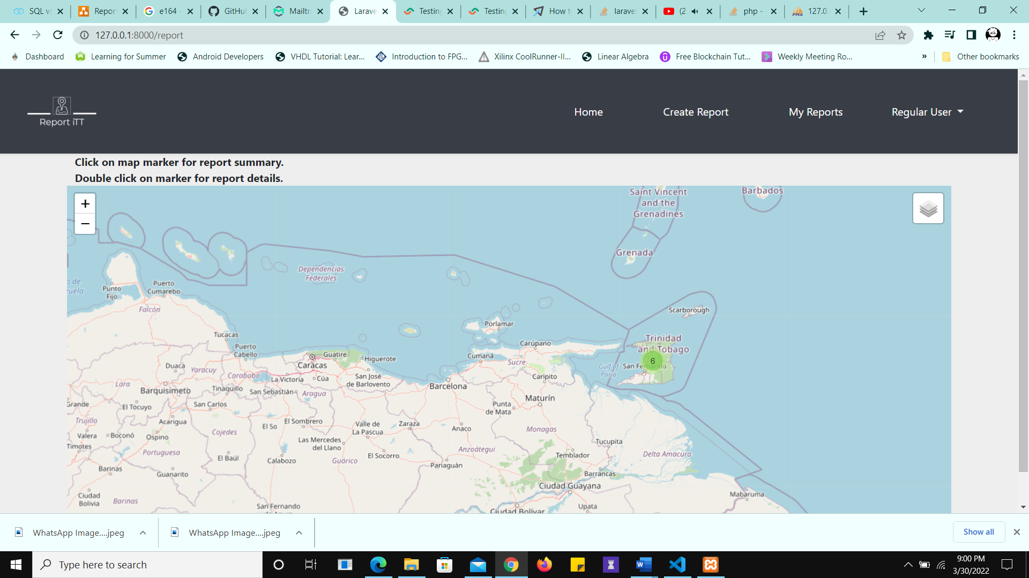

Figure 13 Marker Clustering

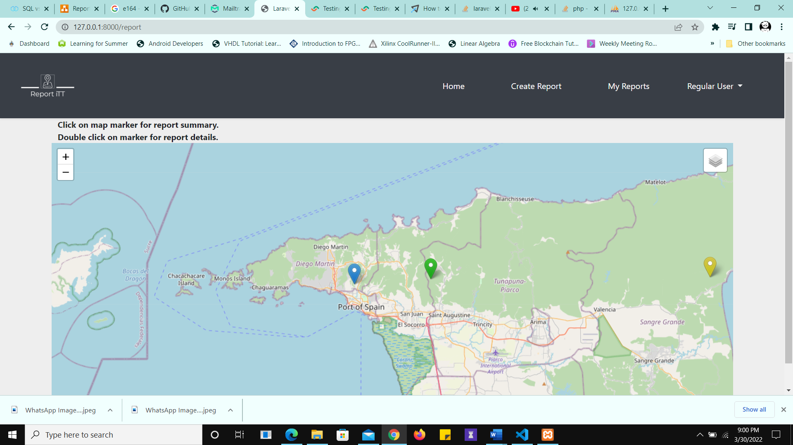

Figure 14 Marker Uncluttering when zoomed in

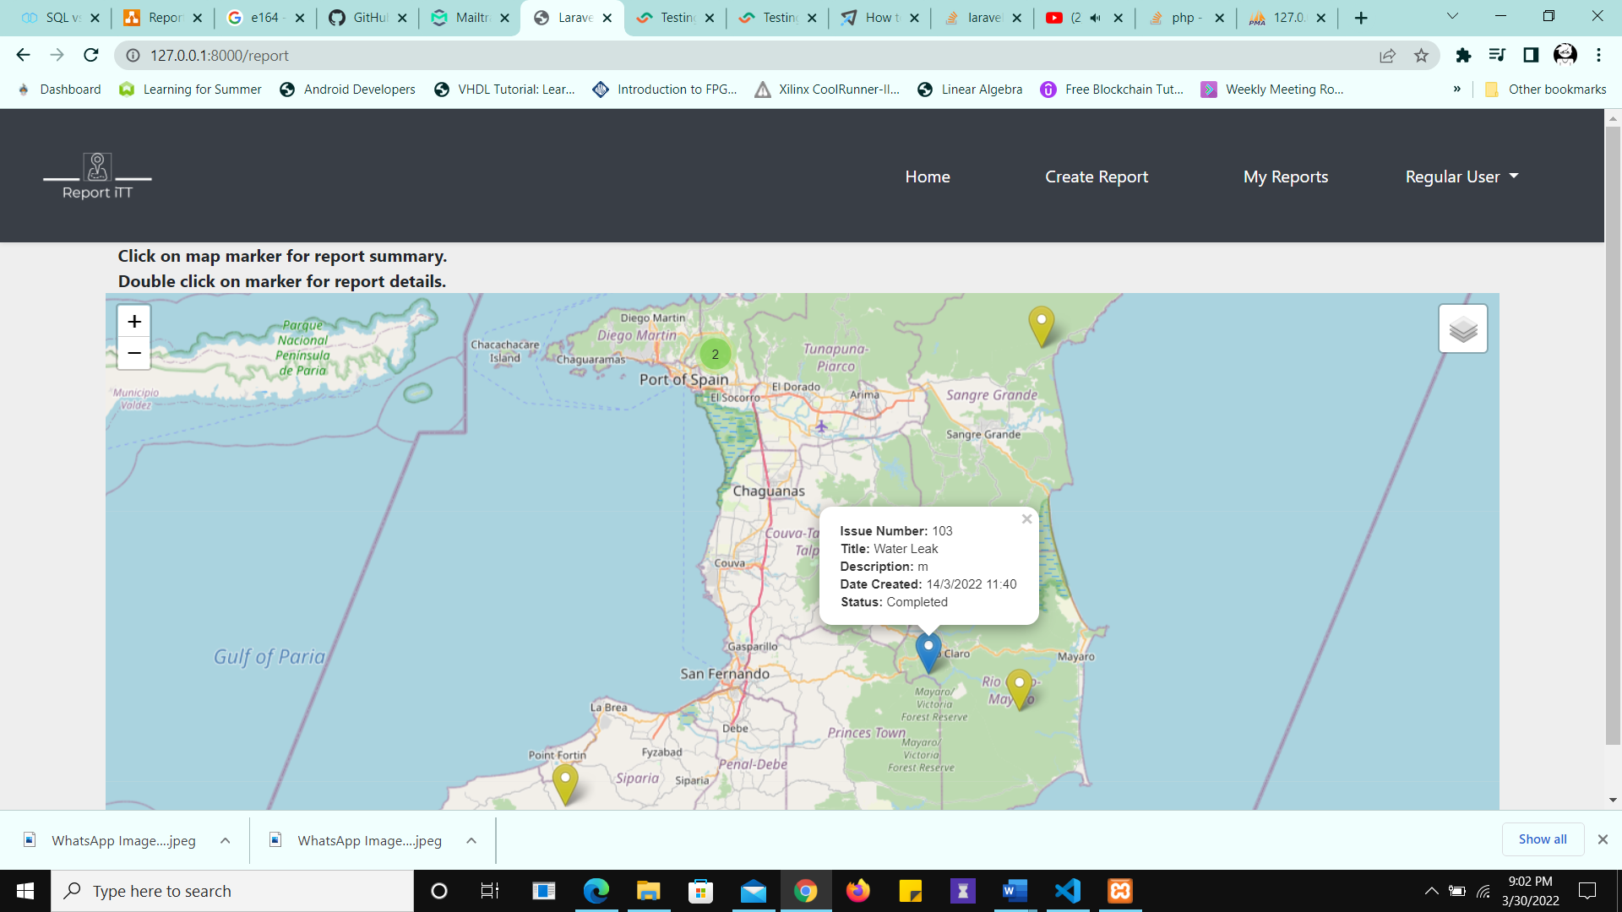

Figure 15 Report Summary Displayed

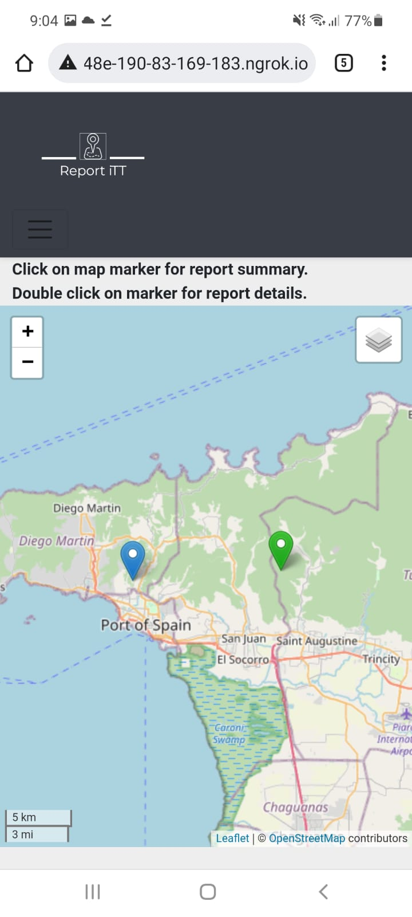

Figure 16 Mobile Uncluttered View

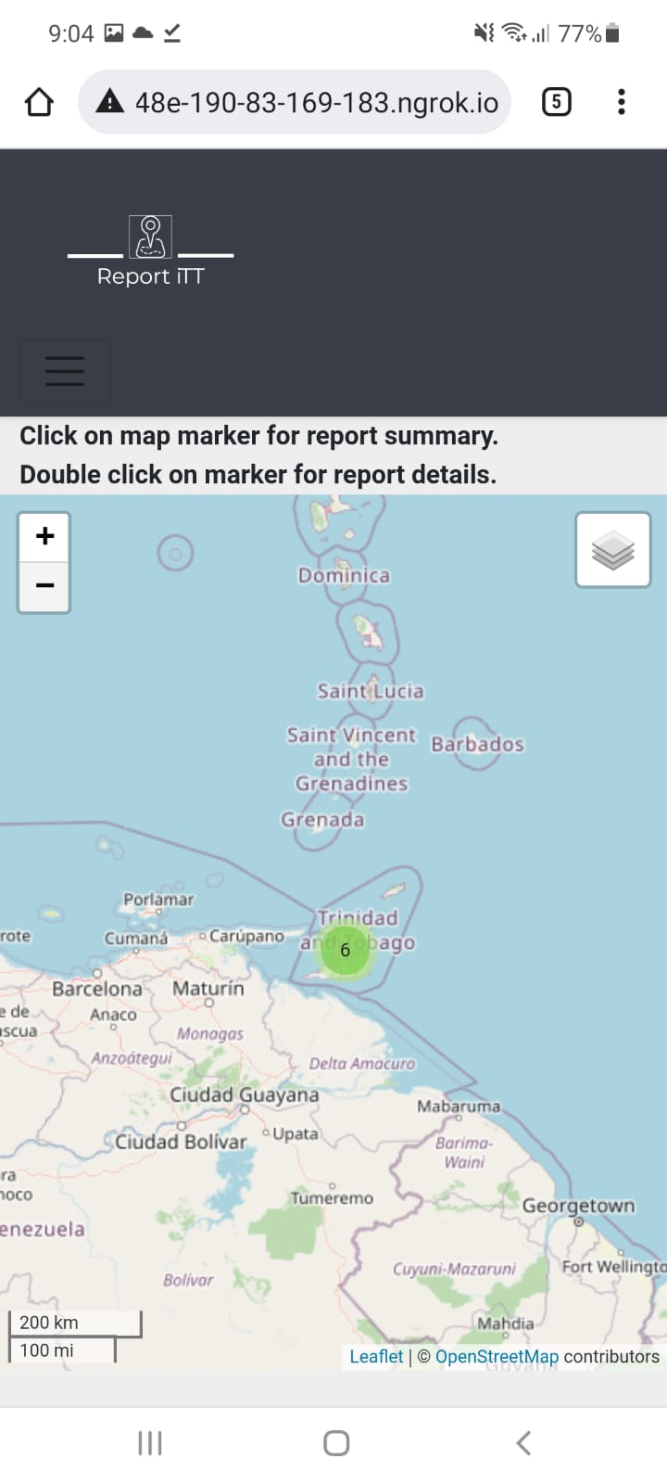

Figure 17 Clustered markers mobile

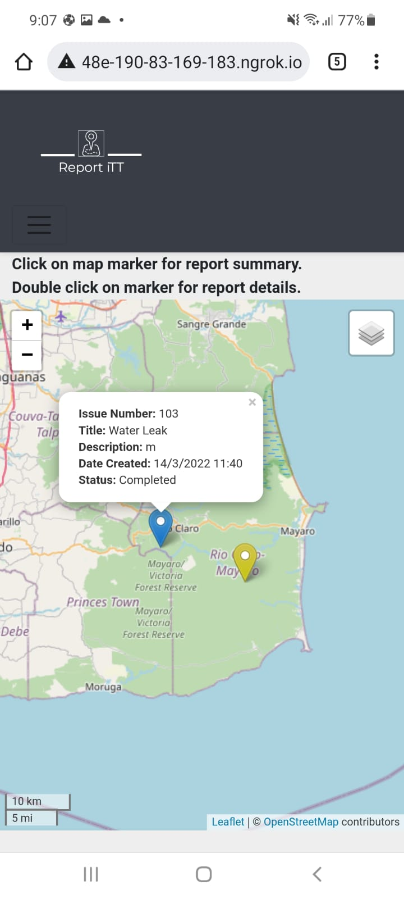

Figure 18 Marker popup view

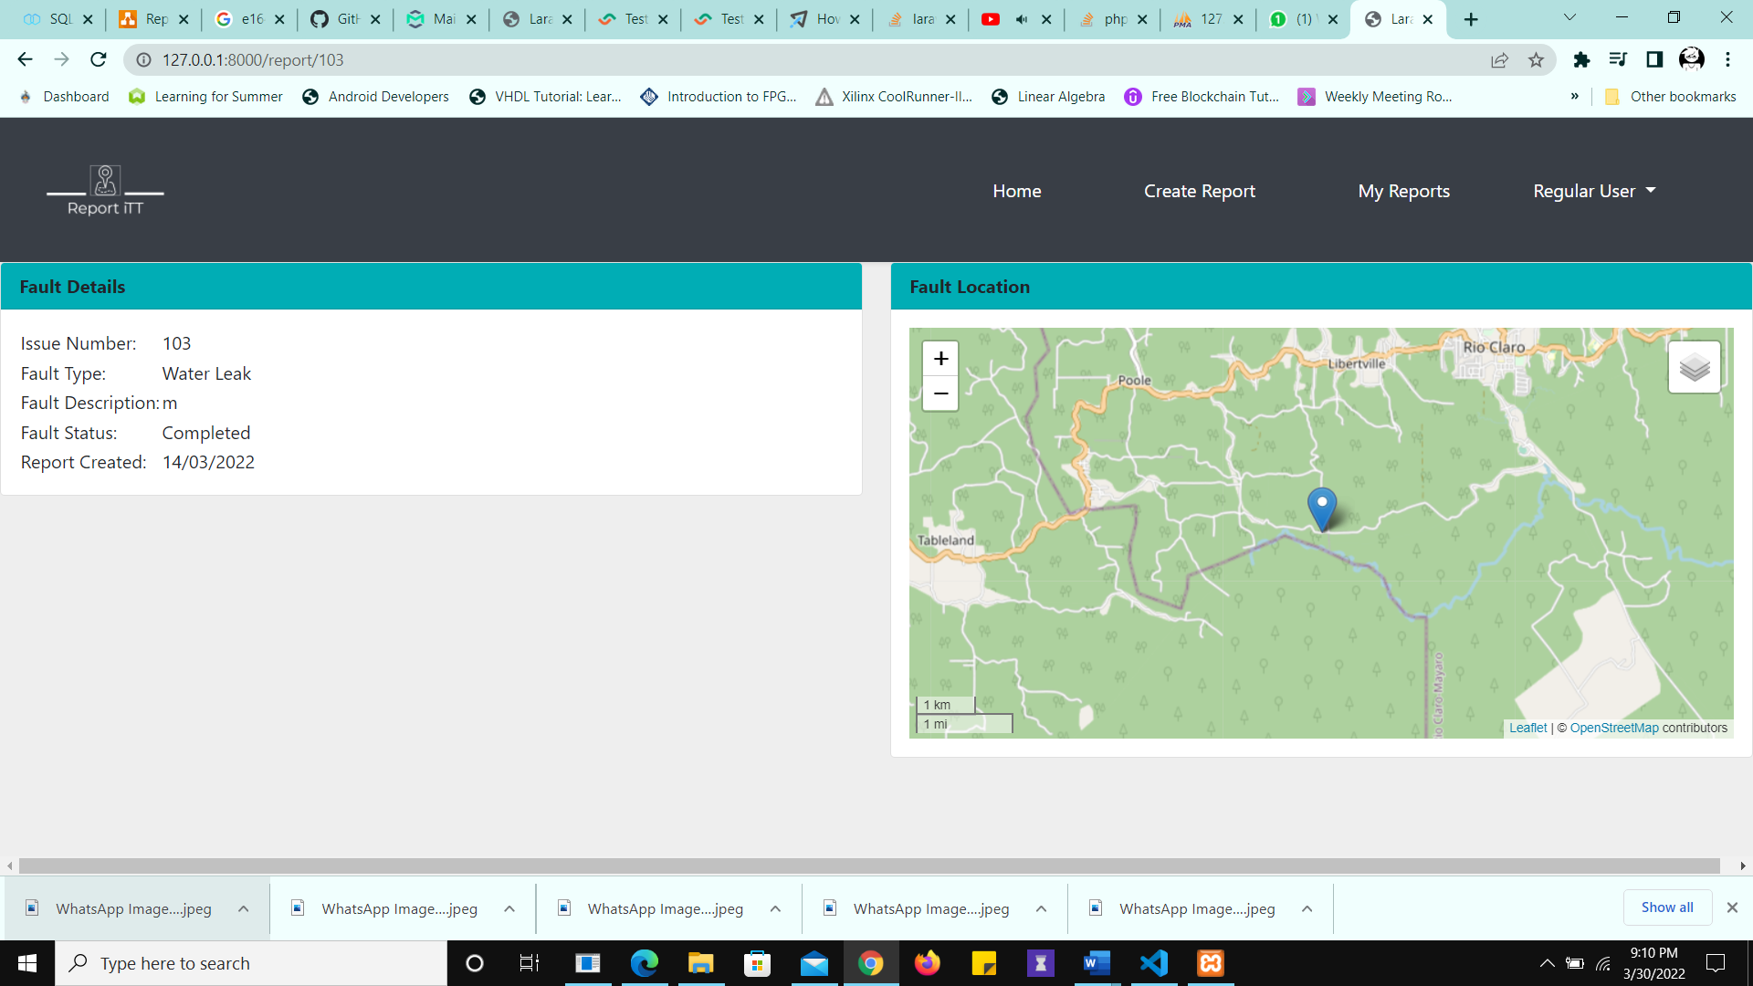

Figure 19 User redirected to the Report Details for the Marker

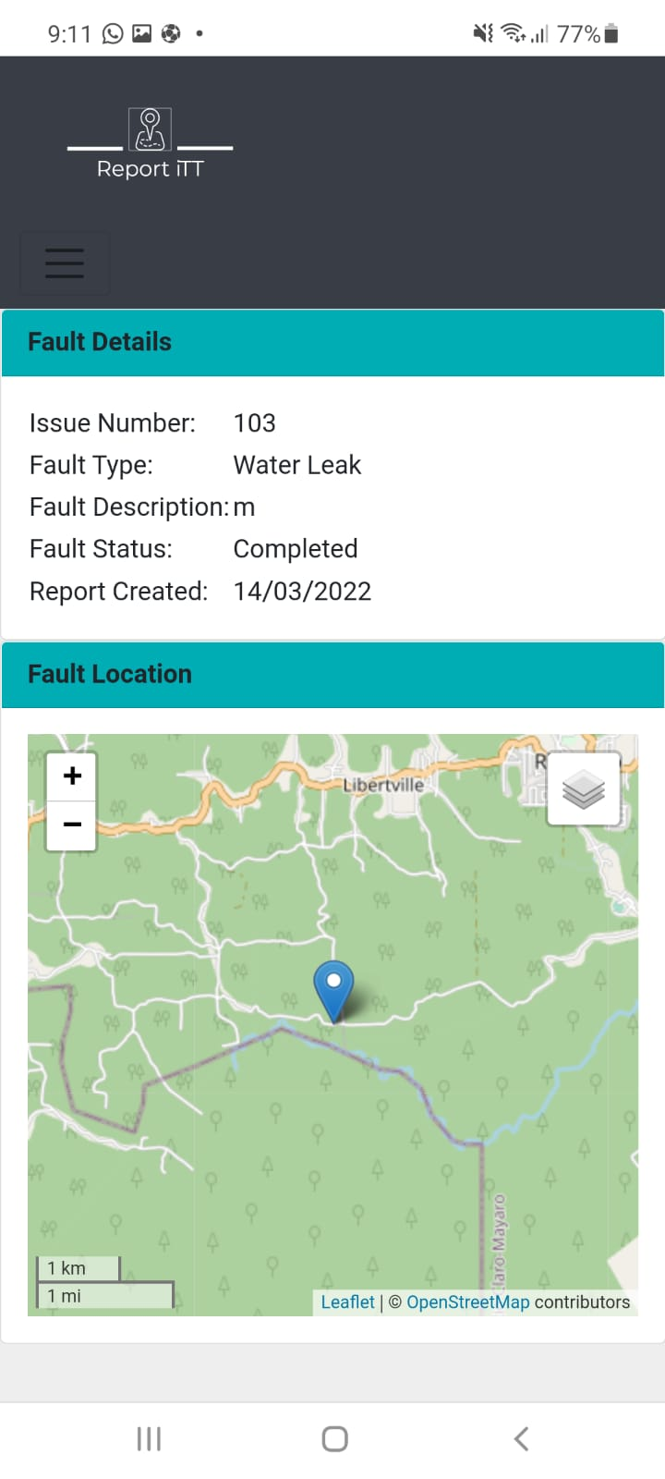

Figure 20 User redirected to the Report Details for the Marker (mobile view)

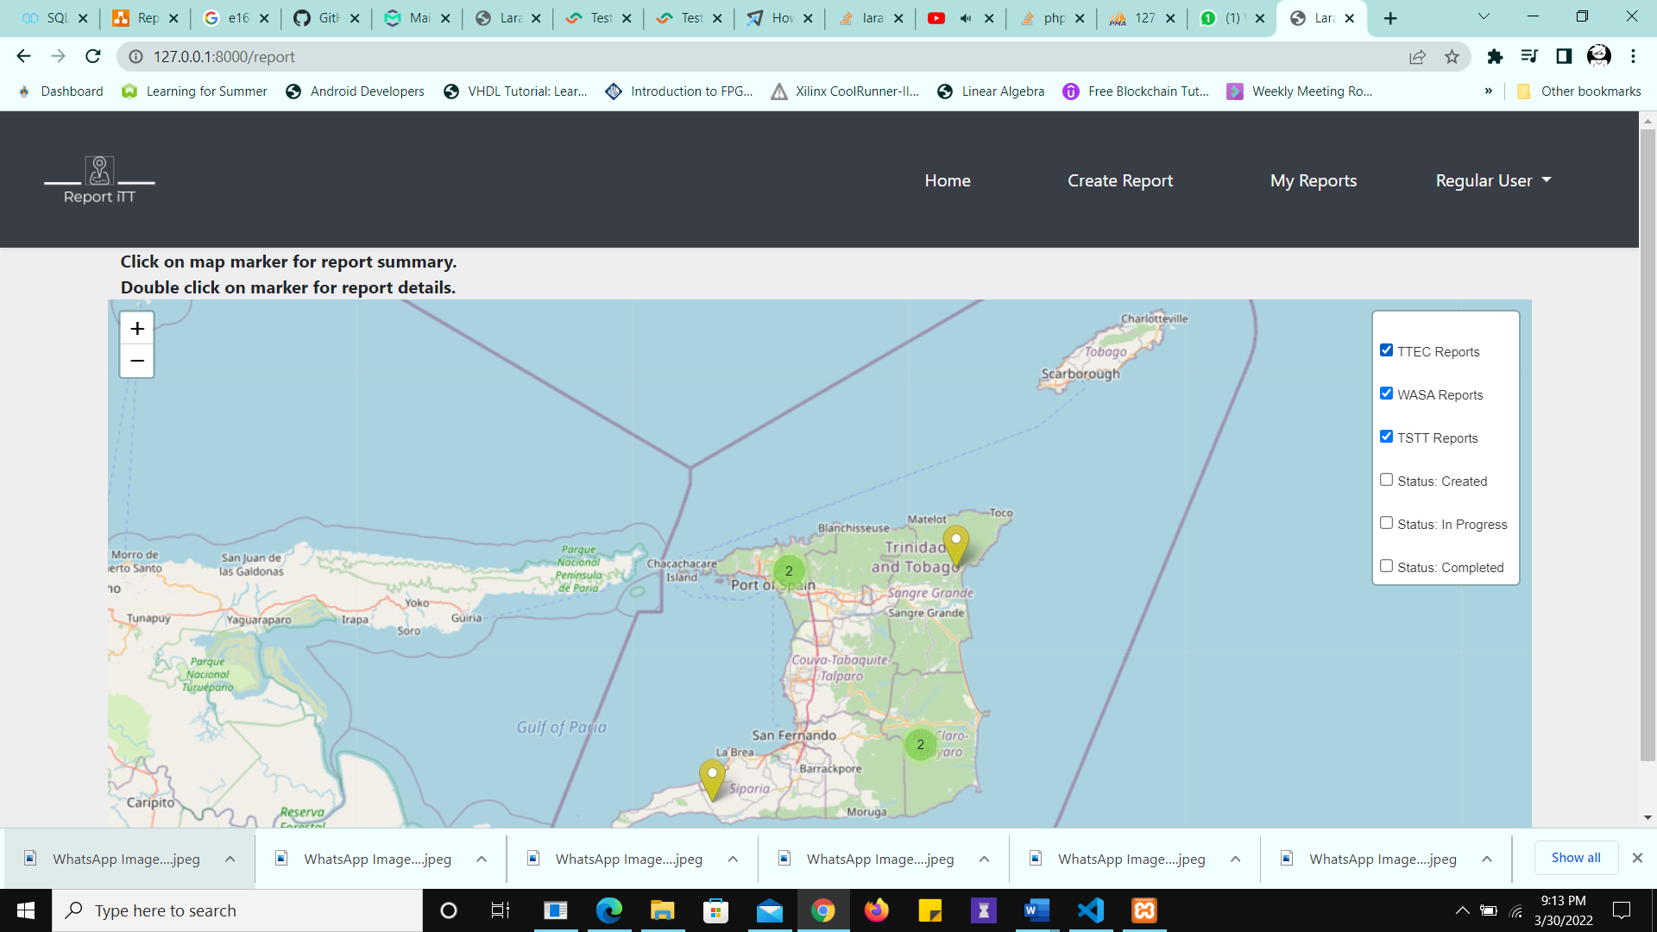

Figure 21 Provider Filters Applied

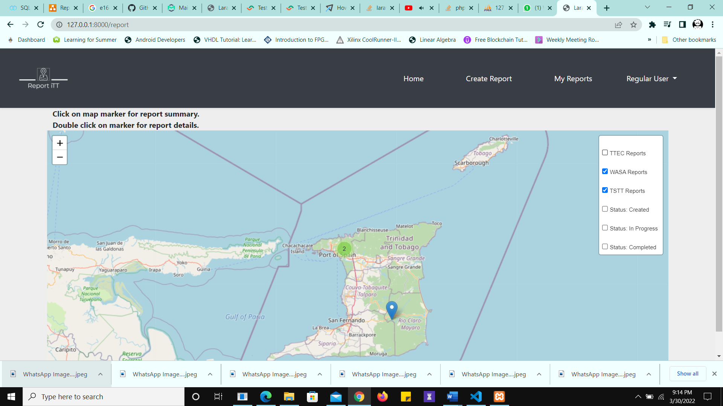

Figure 22 TTEC Filter Deselected

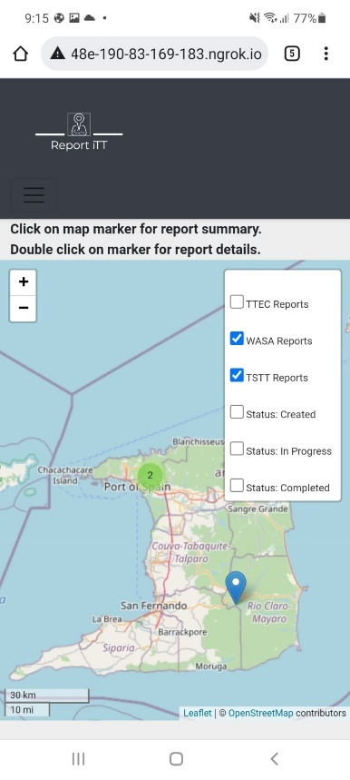

Figure 23 TTEC Filter Deselected (mobile)

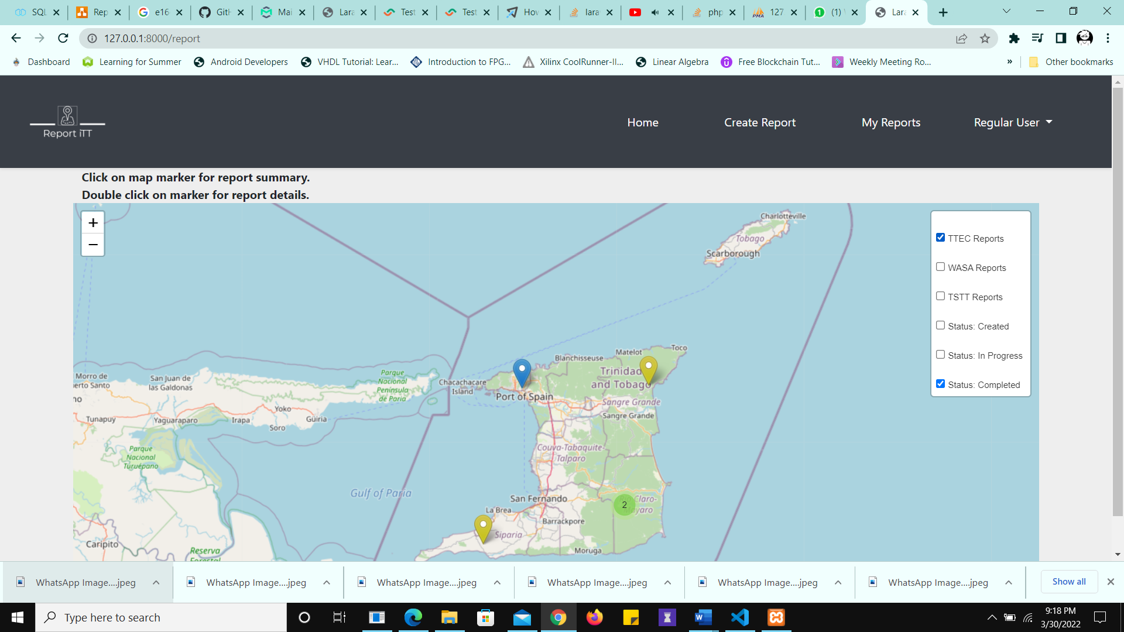

Figure 24 Both filters are applied, however, even though the WASA filter is deselected, the report still shows as it is "completed"

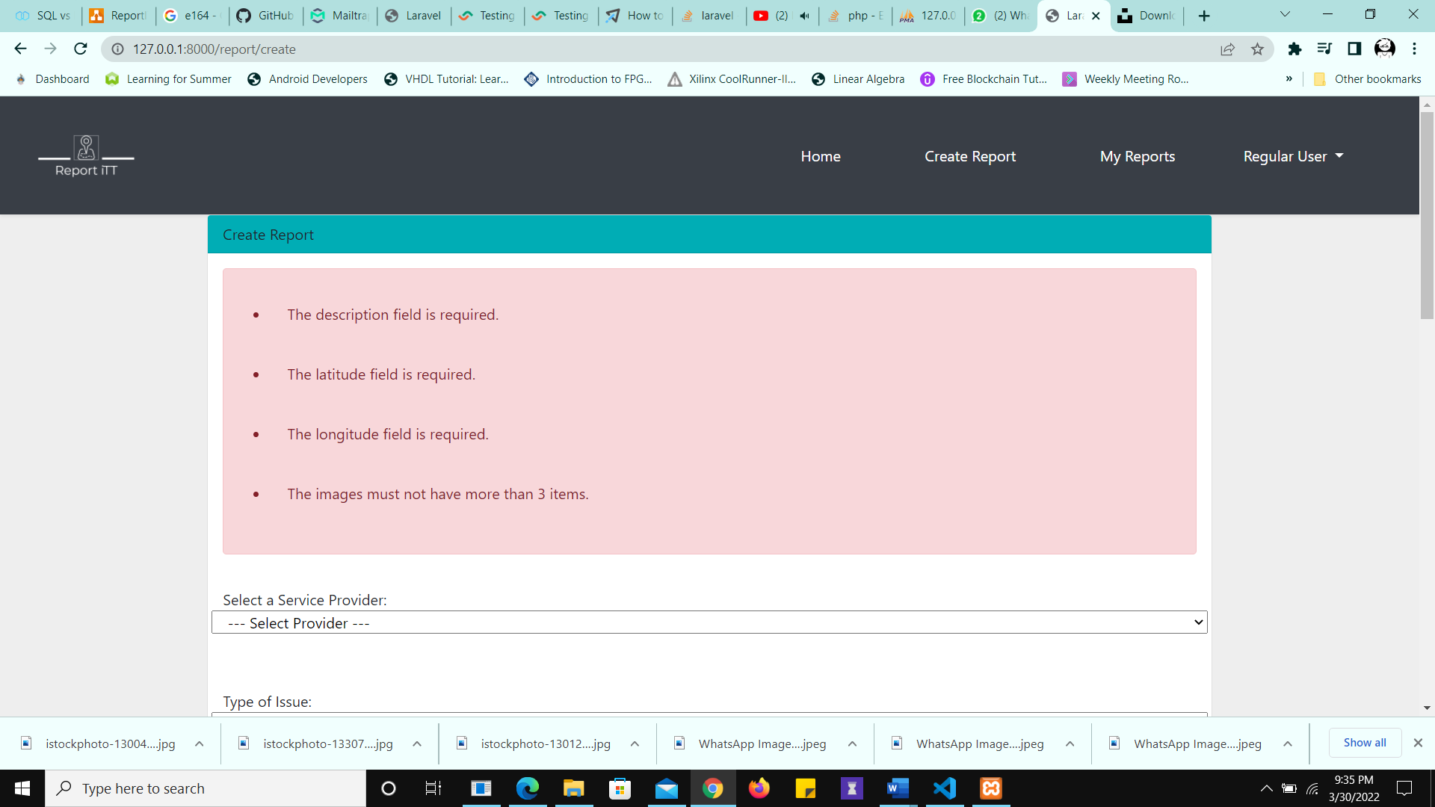

Figure 25 Error Message Returned to the User

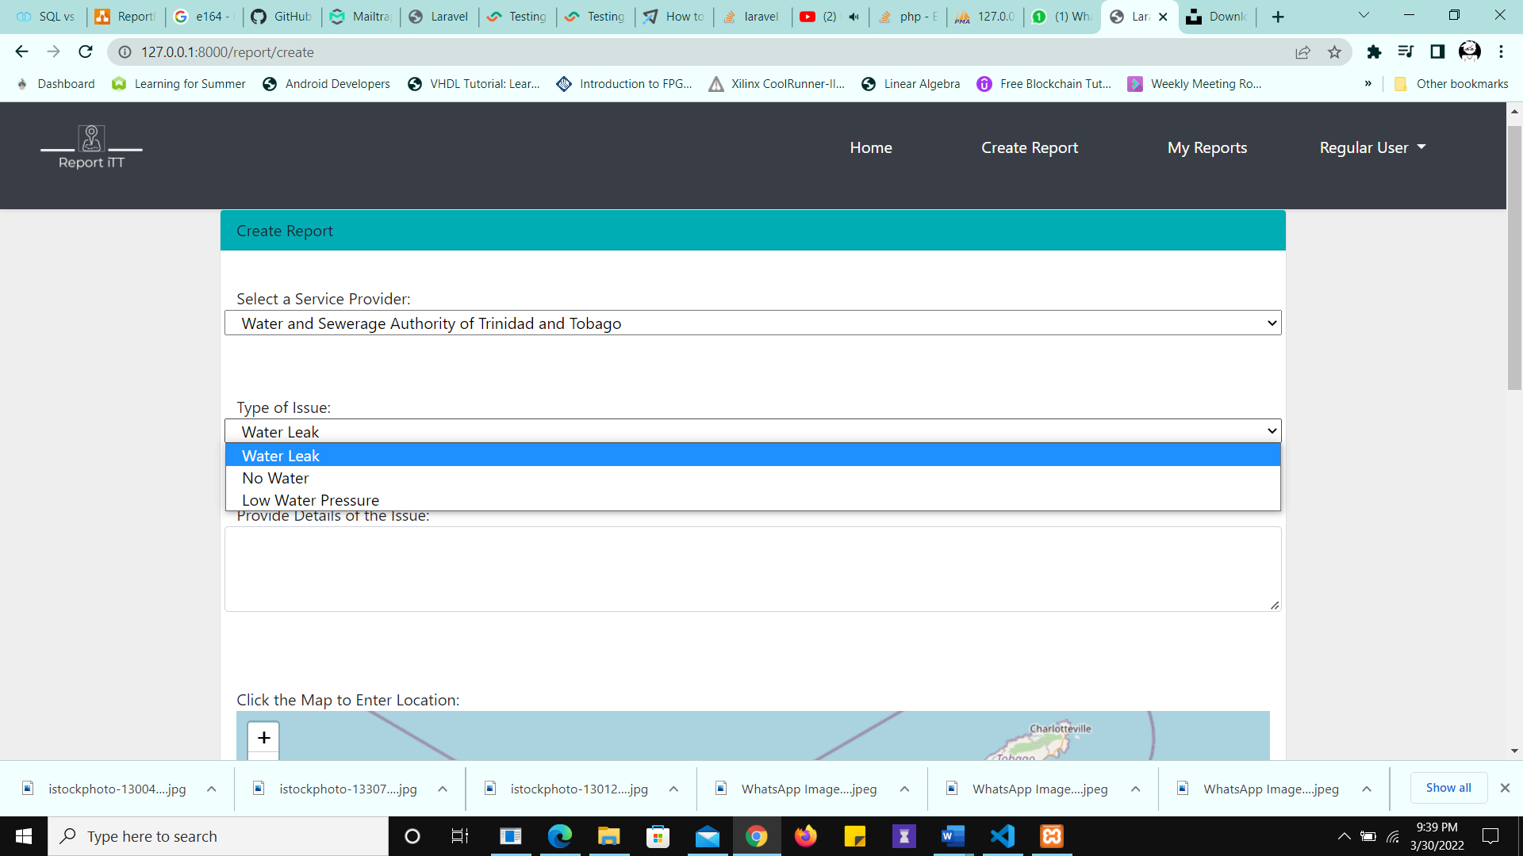

Figure 26 Issues loaded are related to the provider chosen (WASA)

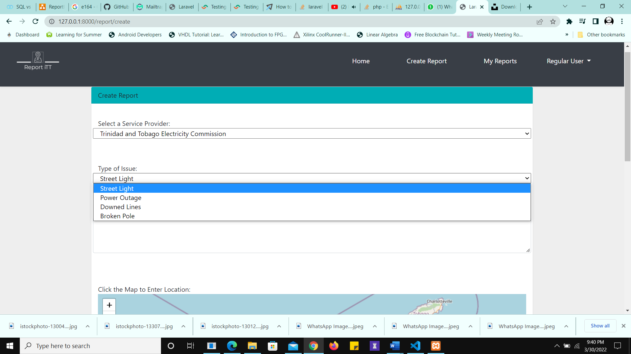

Figure 27 Issues loaded are related to the provider chosen (TTEC)

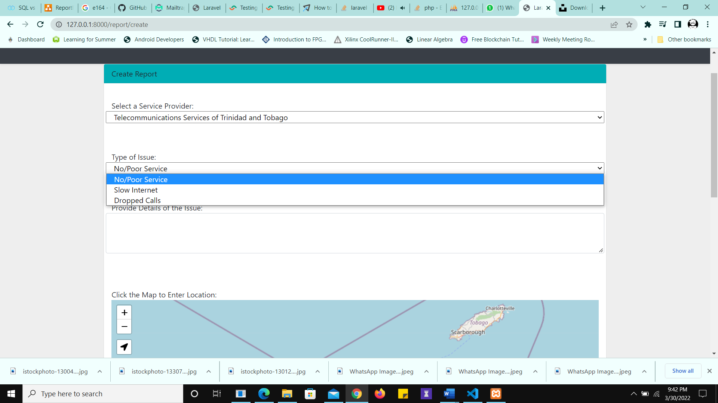

Figure 28 Issues loaded are related to the provider chosen (TSTT)

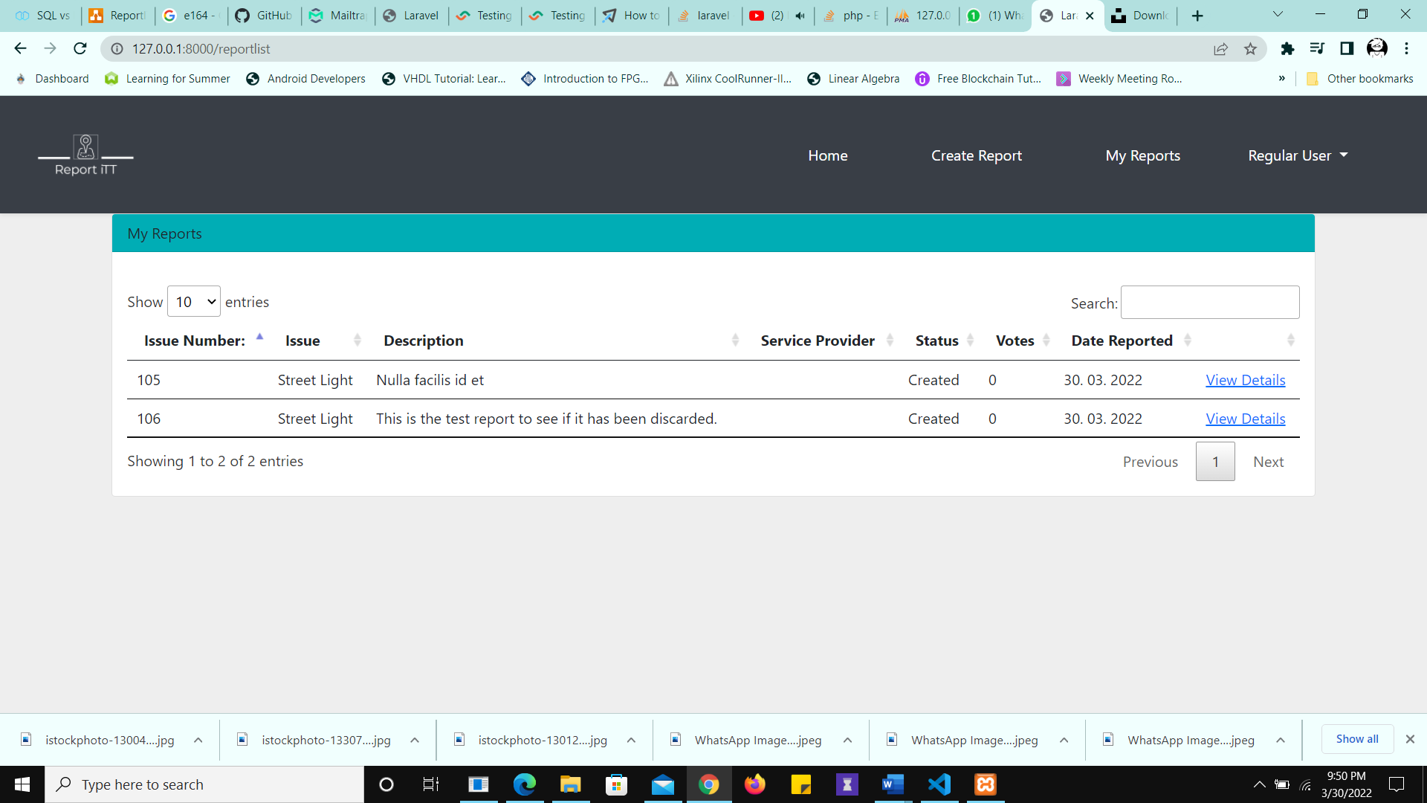

Figure 29 Report Created

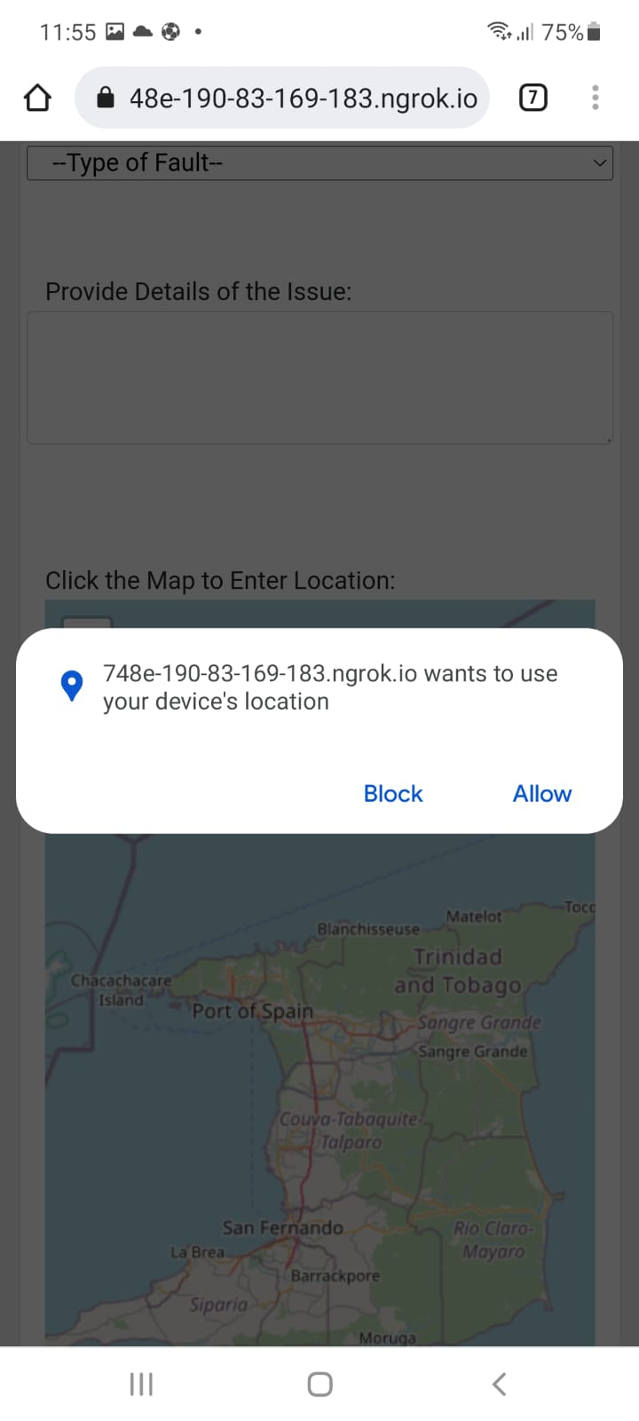

Figure 30 The User is prompted when the geolocation button is selected

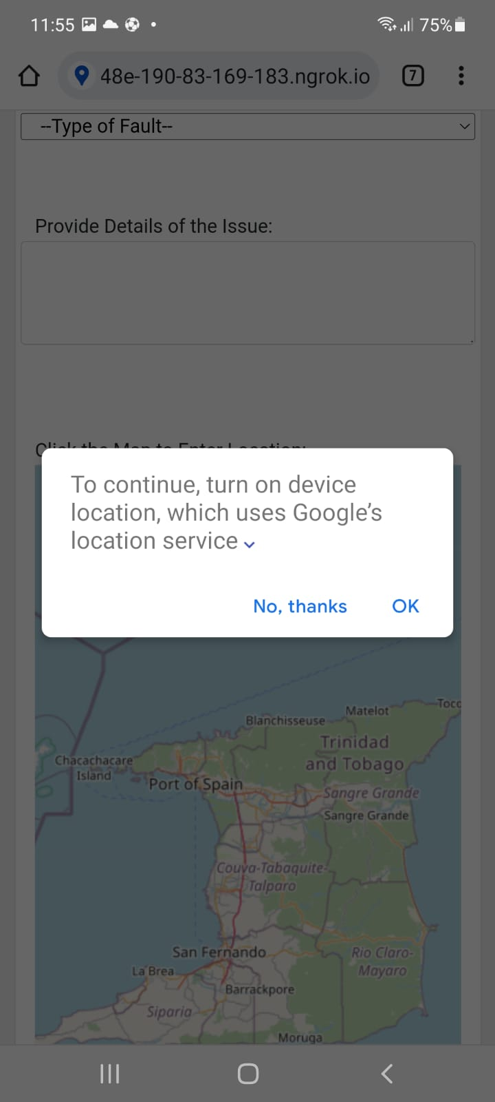

Figure 31 Location permission request

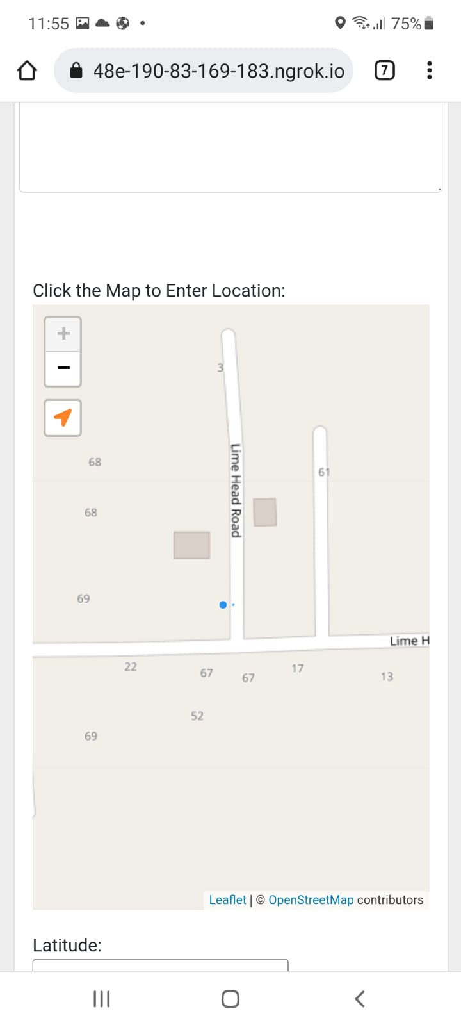

Figure 32 Current user location displayed on map by a pale blue dot. The geolocation API works through HTTPS only

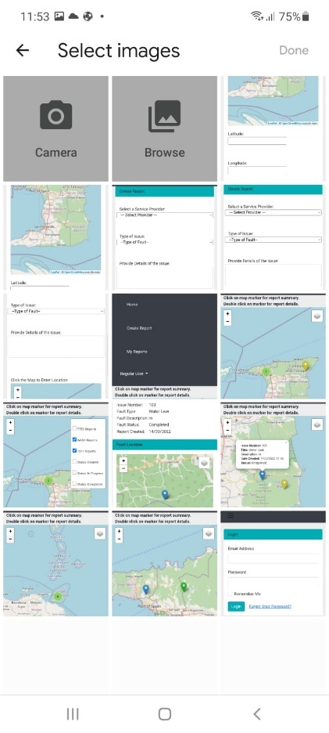

Figure 33 The option to choose from storage and the camera is avalable

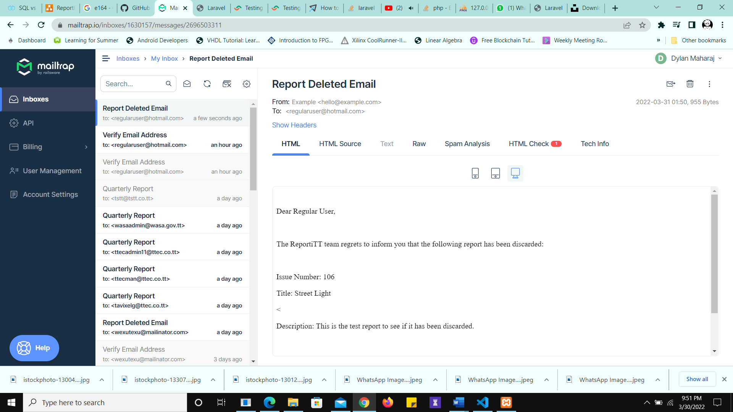

Figure 34 User Notified of Discarded Report

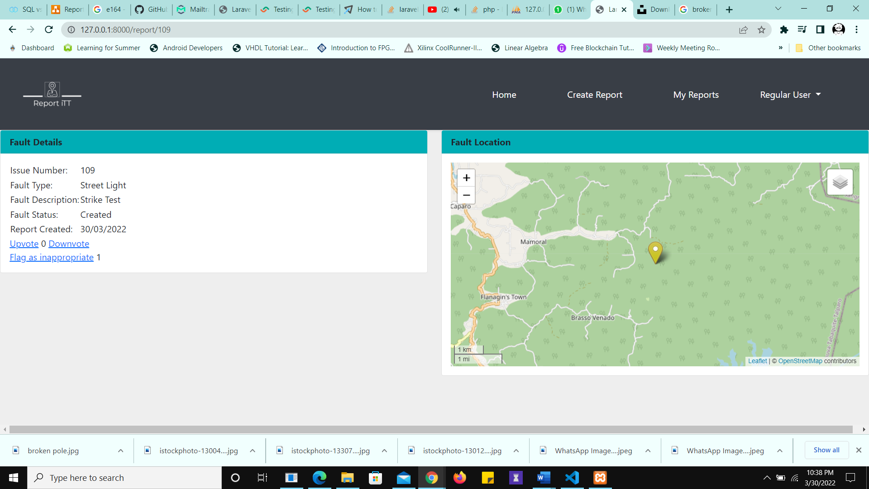

Figure 35 Report is Flagged

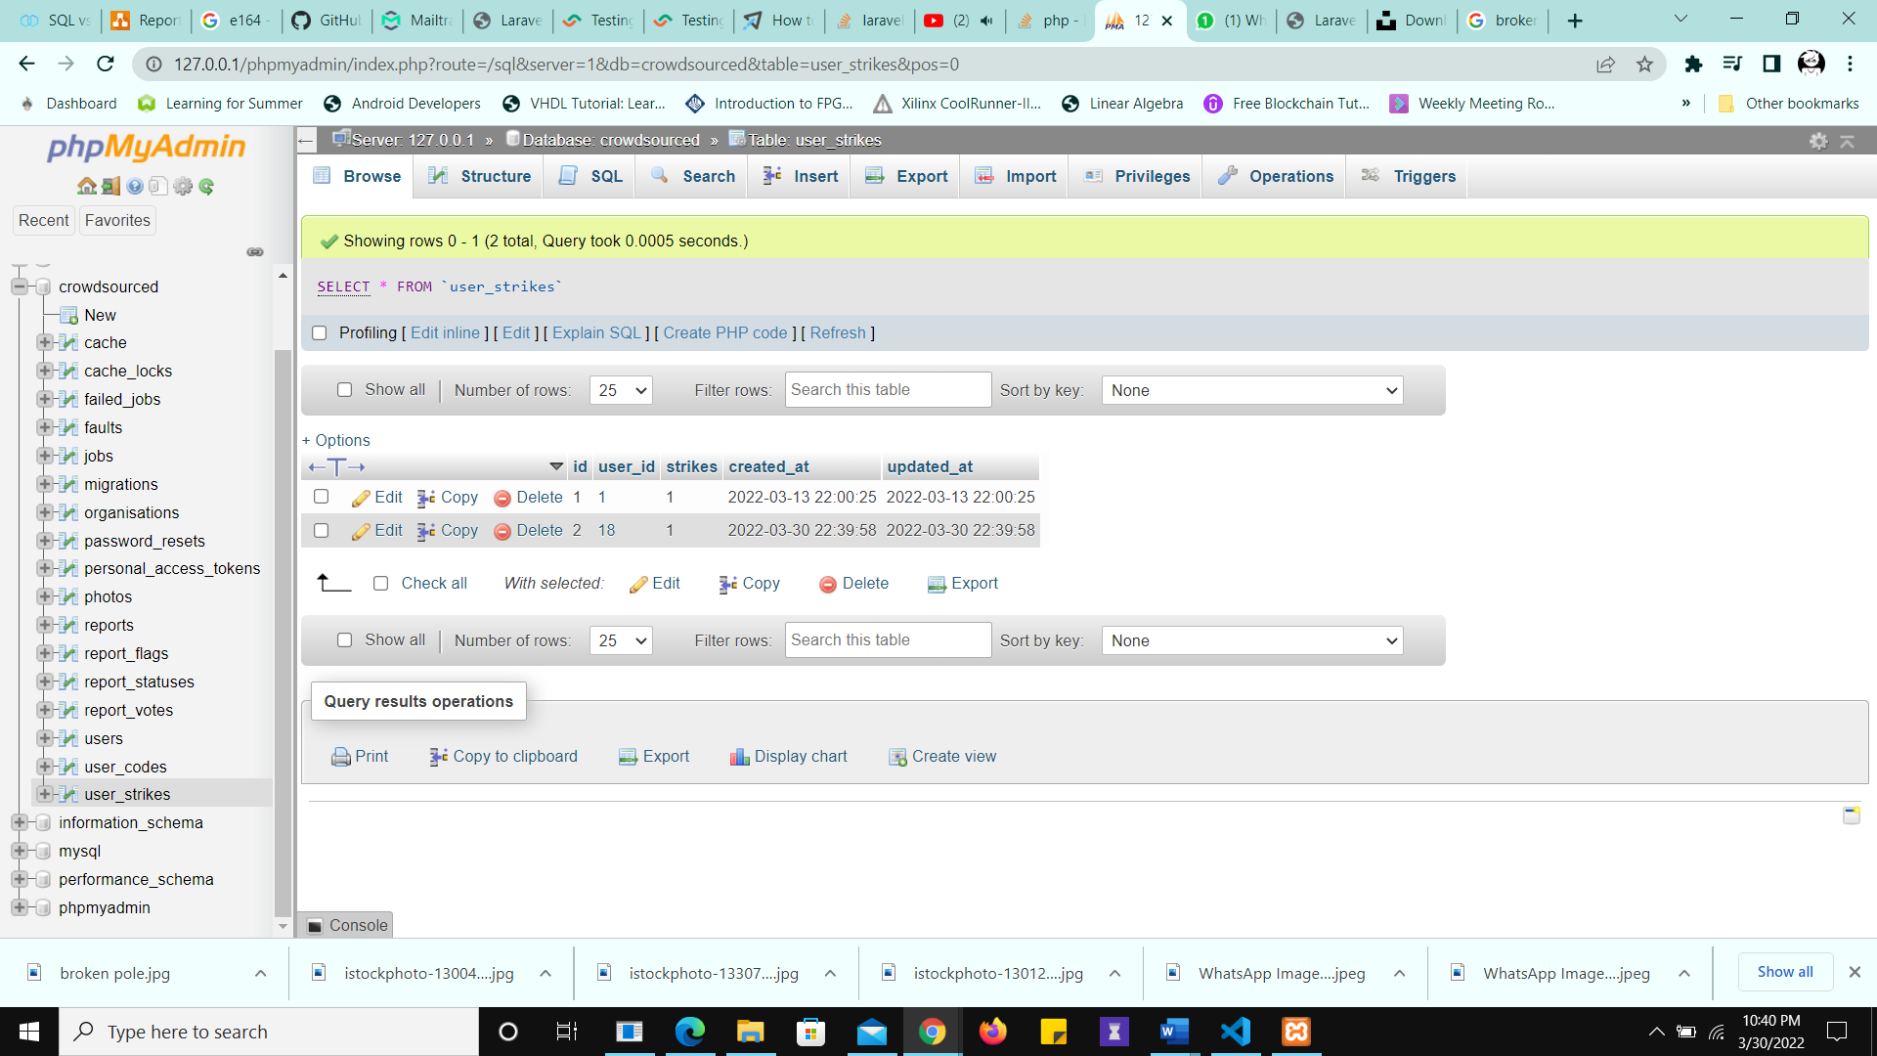

Figure 36 User Receives a Strike

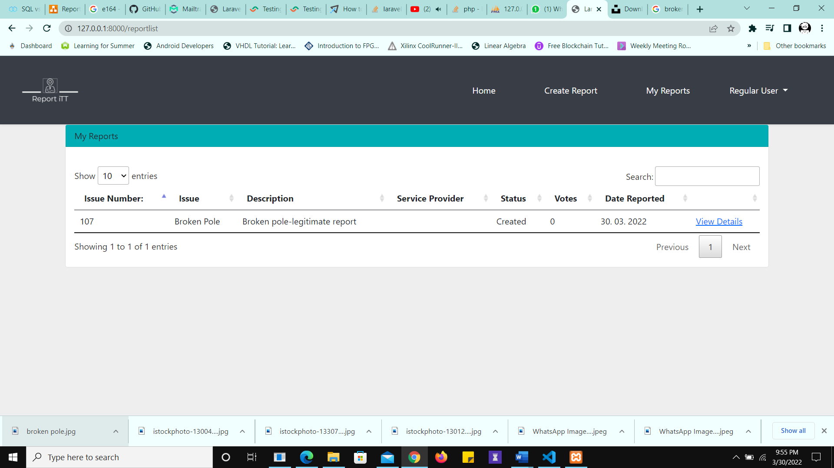

Figure 37 Legitimate Report Created

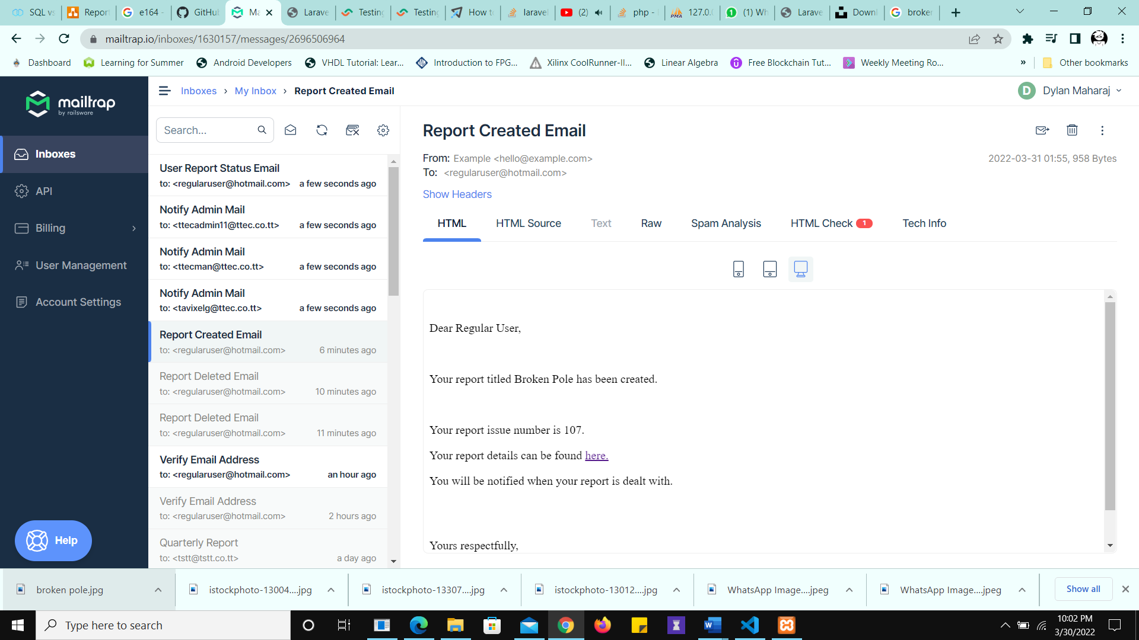

Figure 38 The User is Notified of the Report Creation

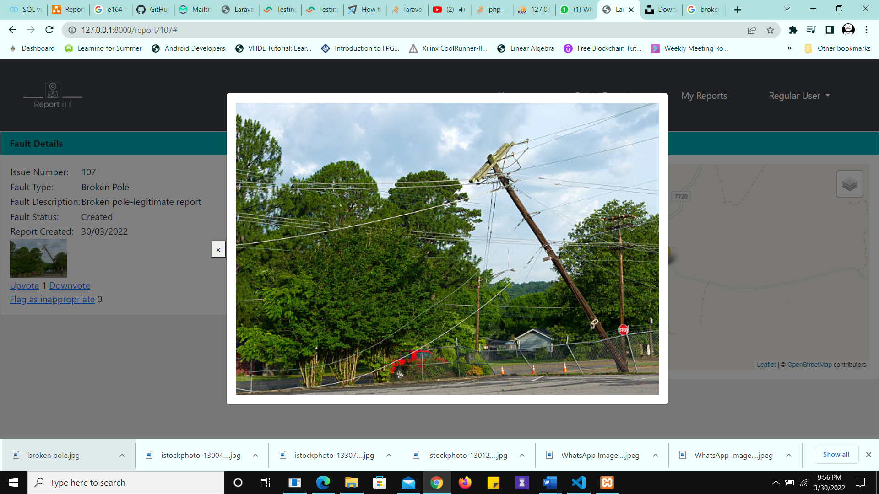

Figure 39 Report Details - Image opens when clicked

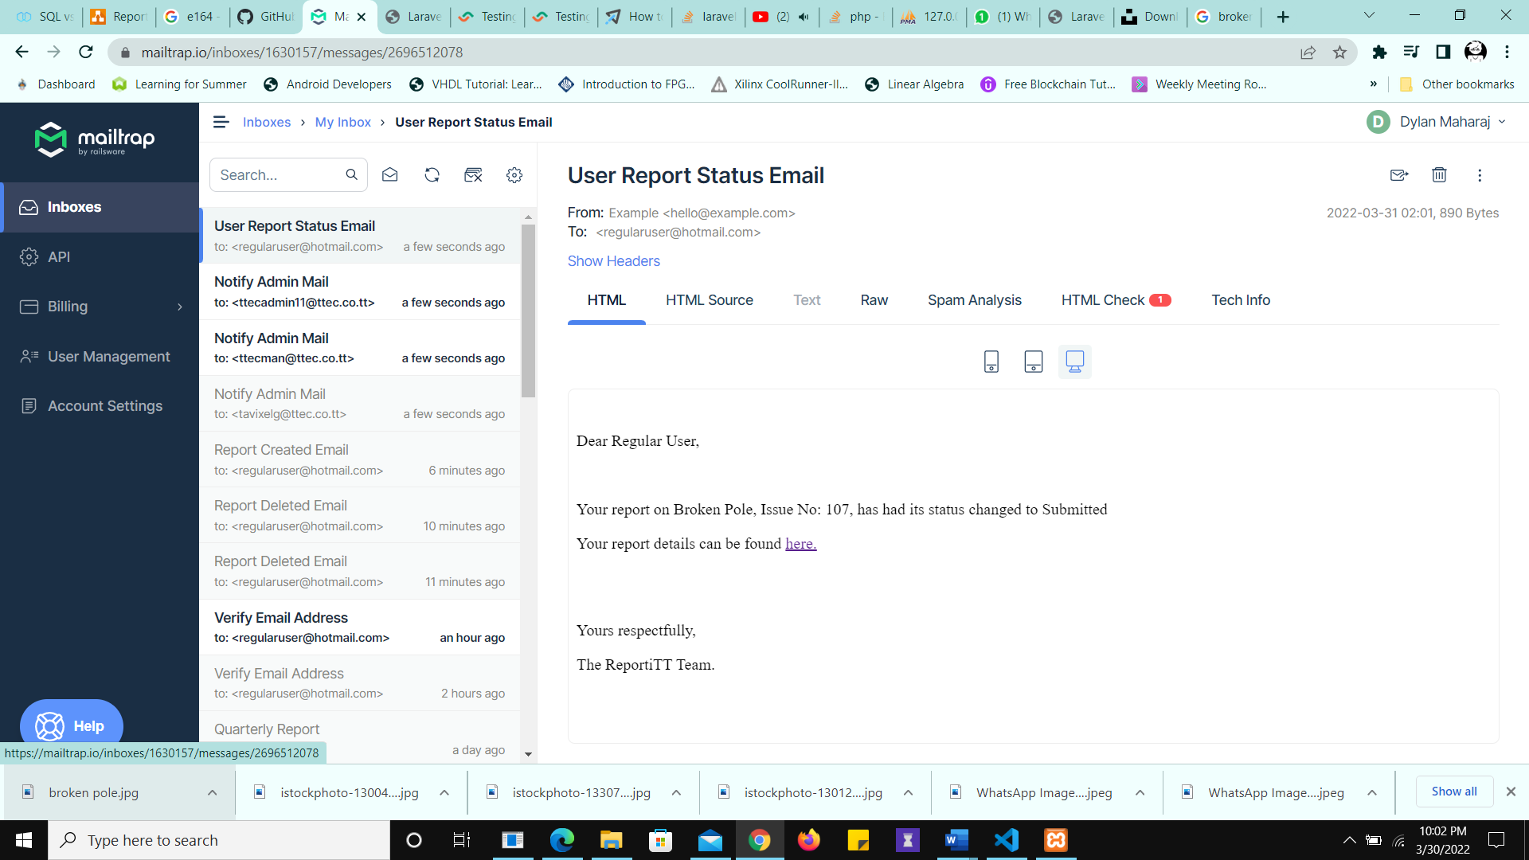

Figure 40 User is Notified of the Status Change

.

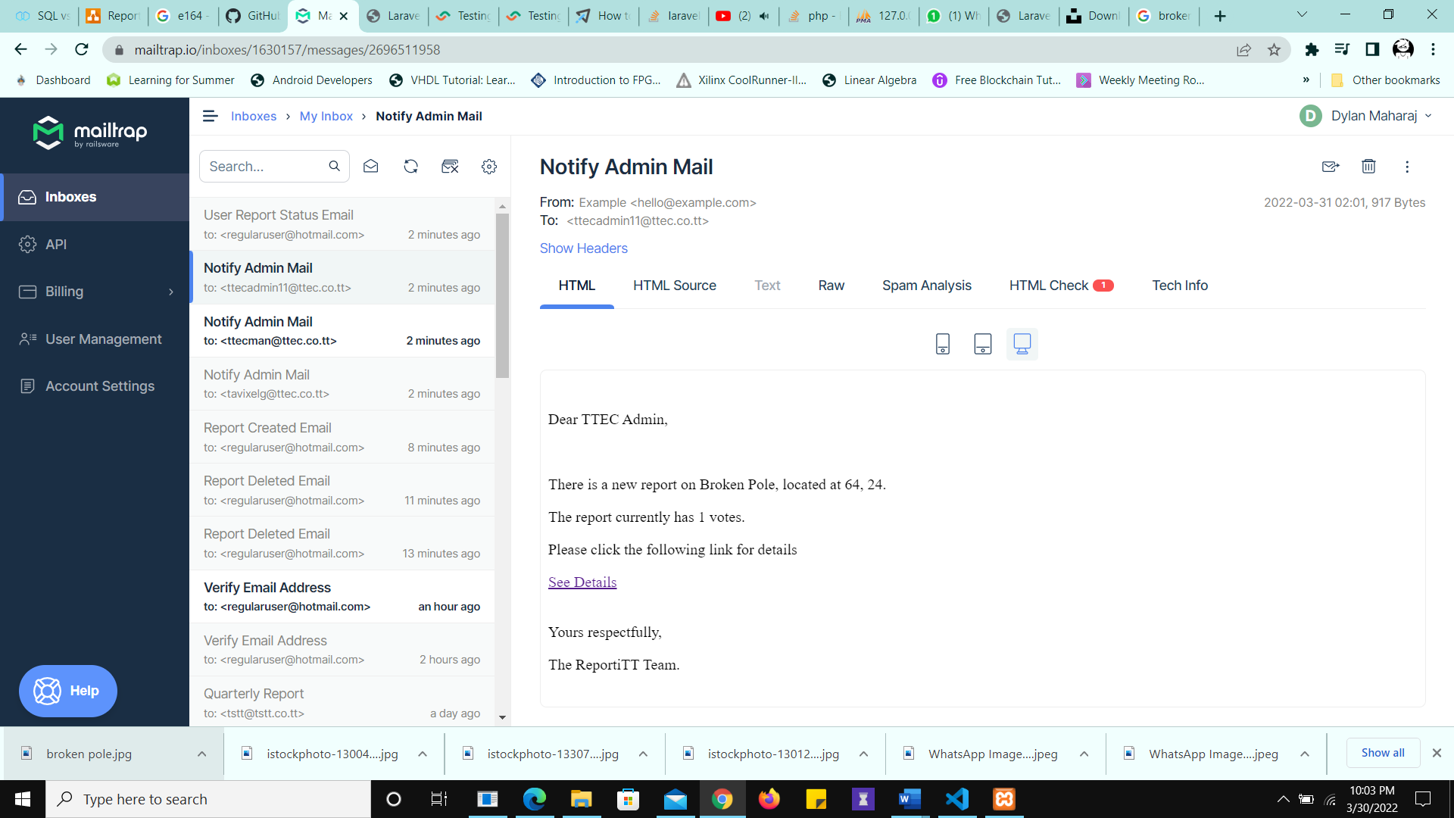

Figure 41 Admin is Notified of the Status Change. Note that all the TTEC admins are notified.

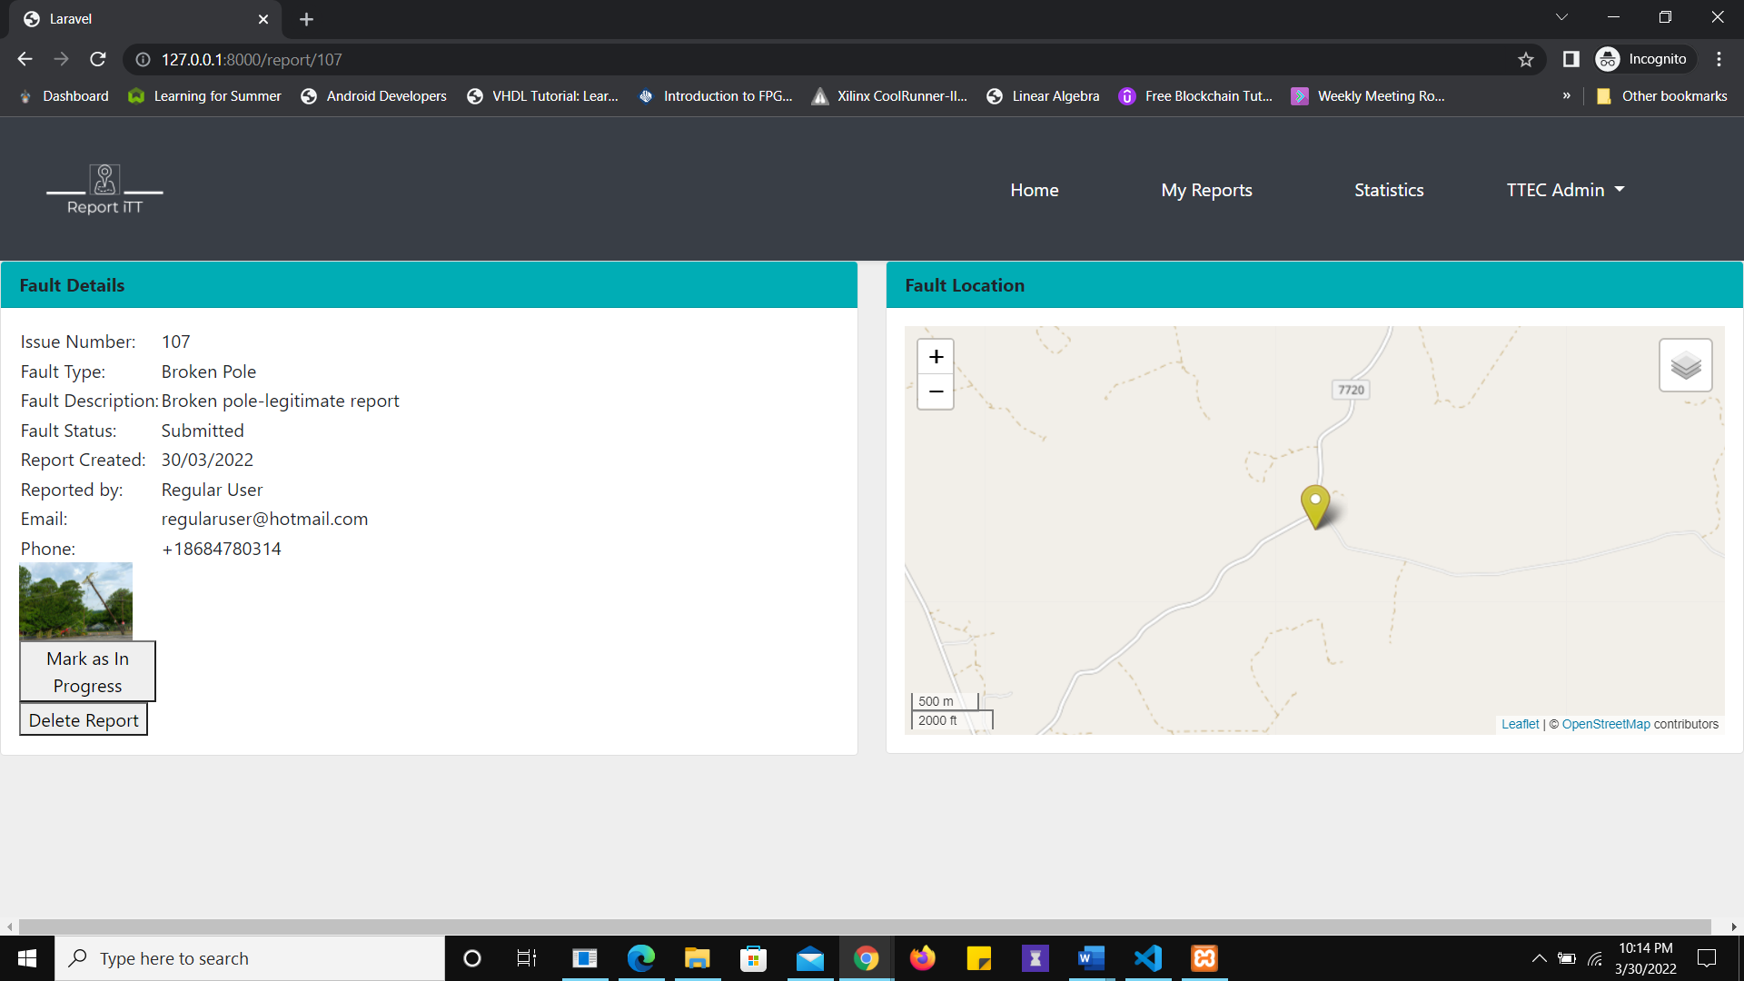

Figure 42 Only the TTEC admin can view/edit report status and manually delete the TTEC report. Service Providers can only edit statuses and view the contact information of those reports belonging to their organisation

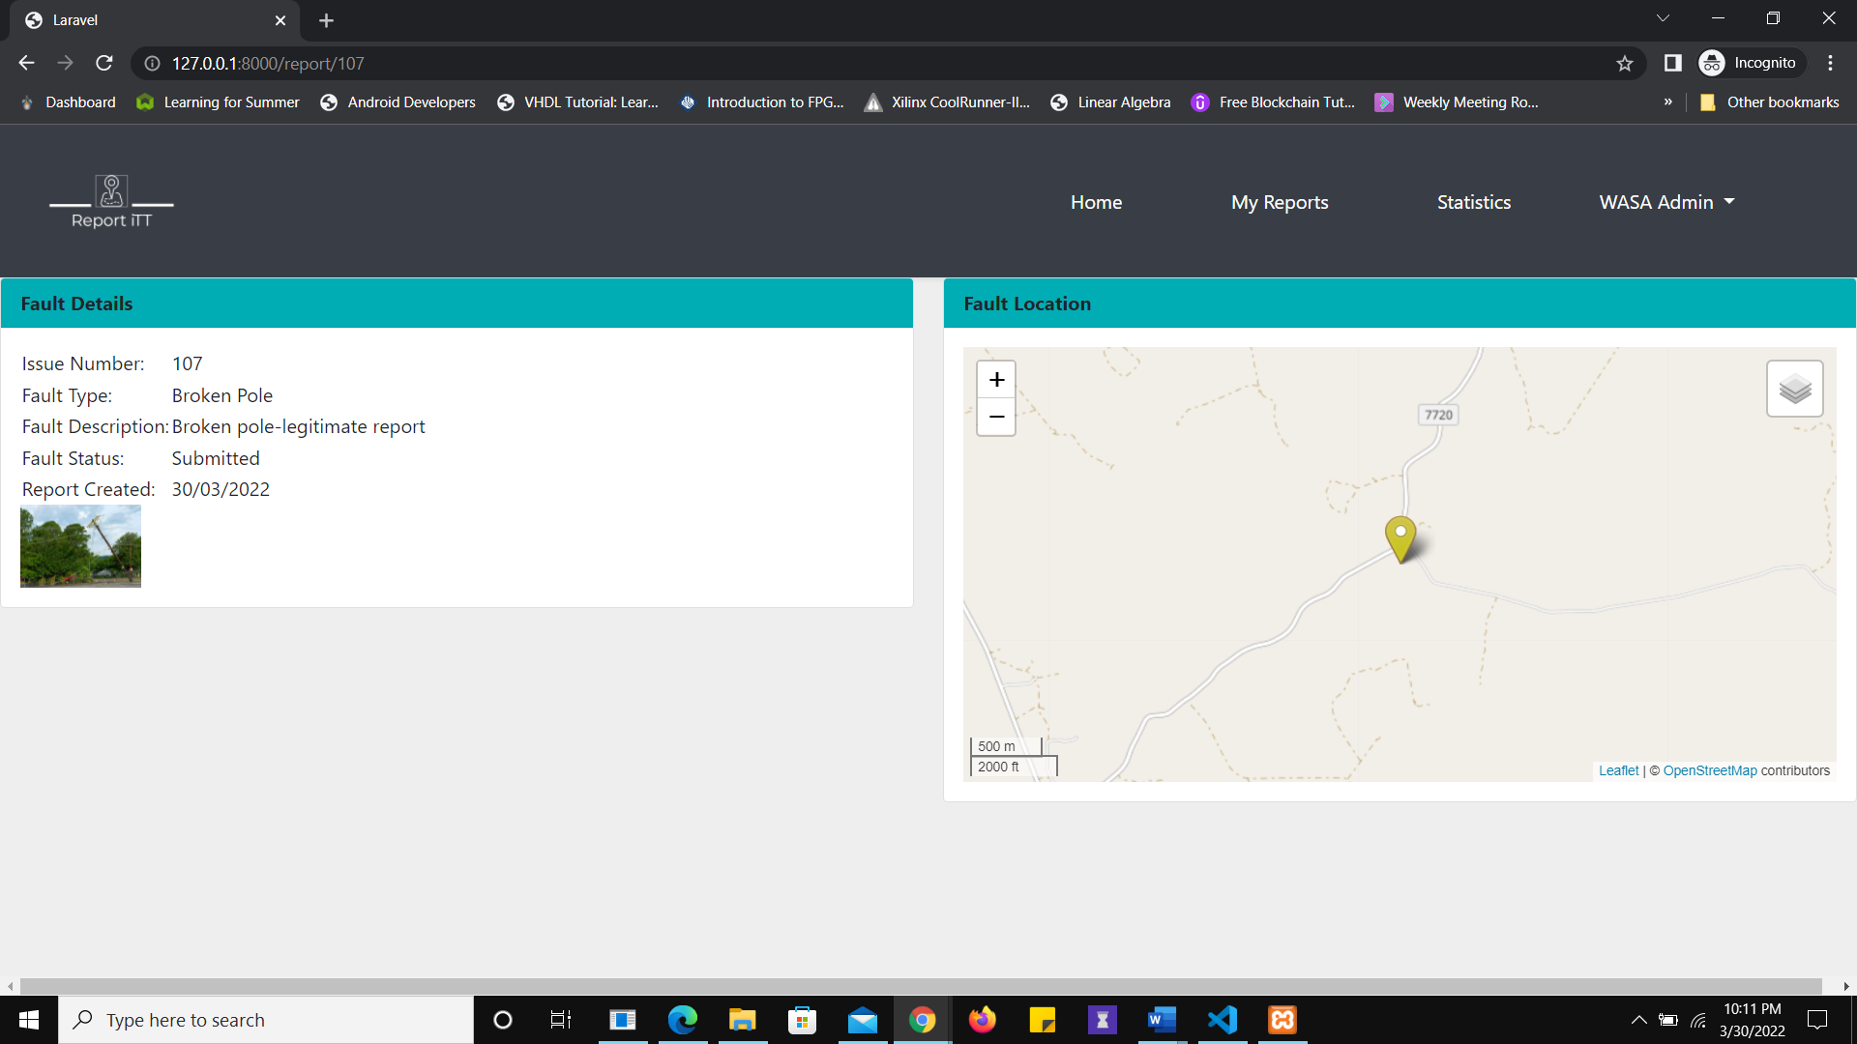

Figure 43 WASA Admin cannot update the status of a TTEC Report

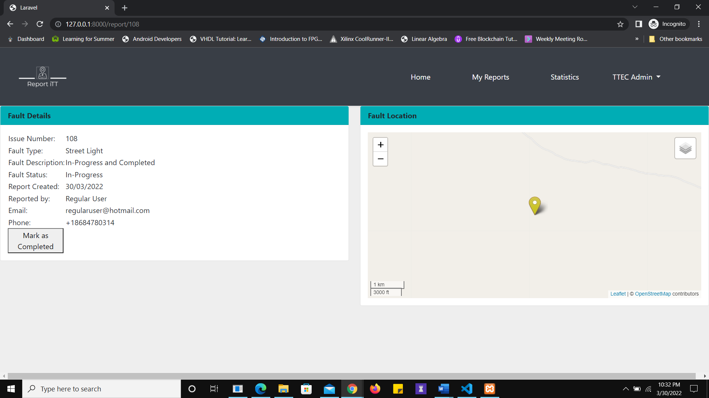

Figure 44 Admin Cannot Delete Report After it is Set to "In-Progress"

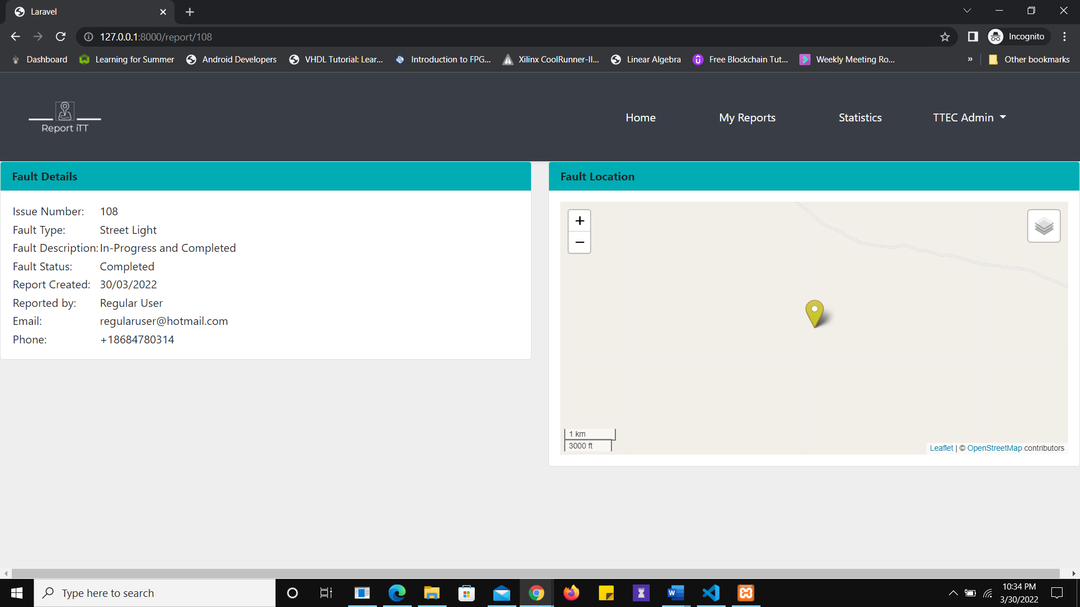

Figure 45 Report status cannot be altered after it is set to "Completed"

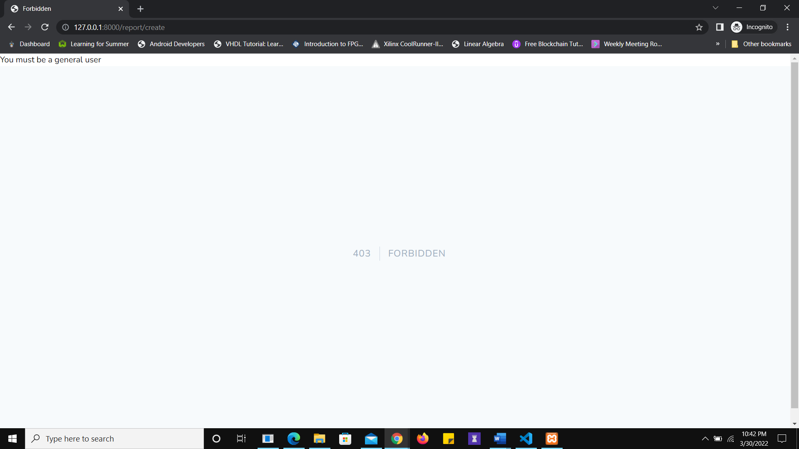

Figure 46 When a Service Provider or Admin tries to access the report by link, they receive an error message. This is due to the access control implemented by the middleware and the gates

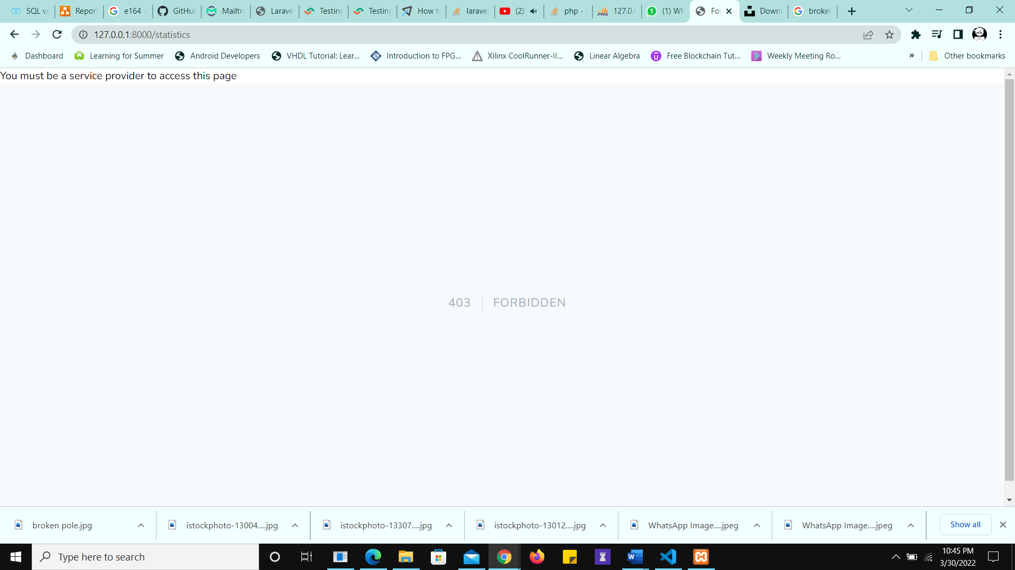

Figure 47 Only Service Providers Can Access the Statistics Page

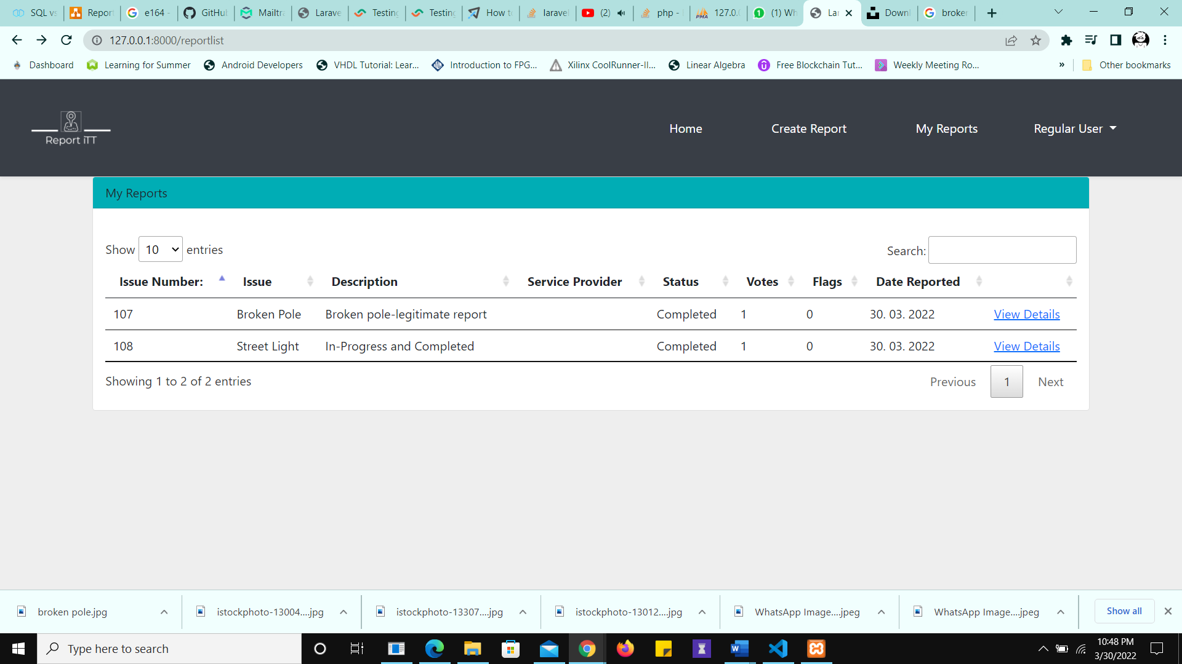

Figure 48 The "My Reports" page shows only the reports created by the user for PUB-class users

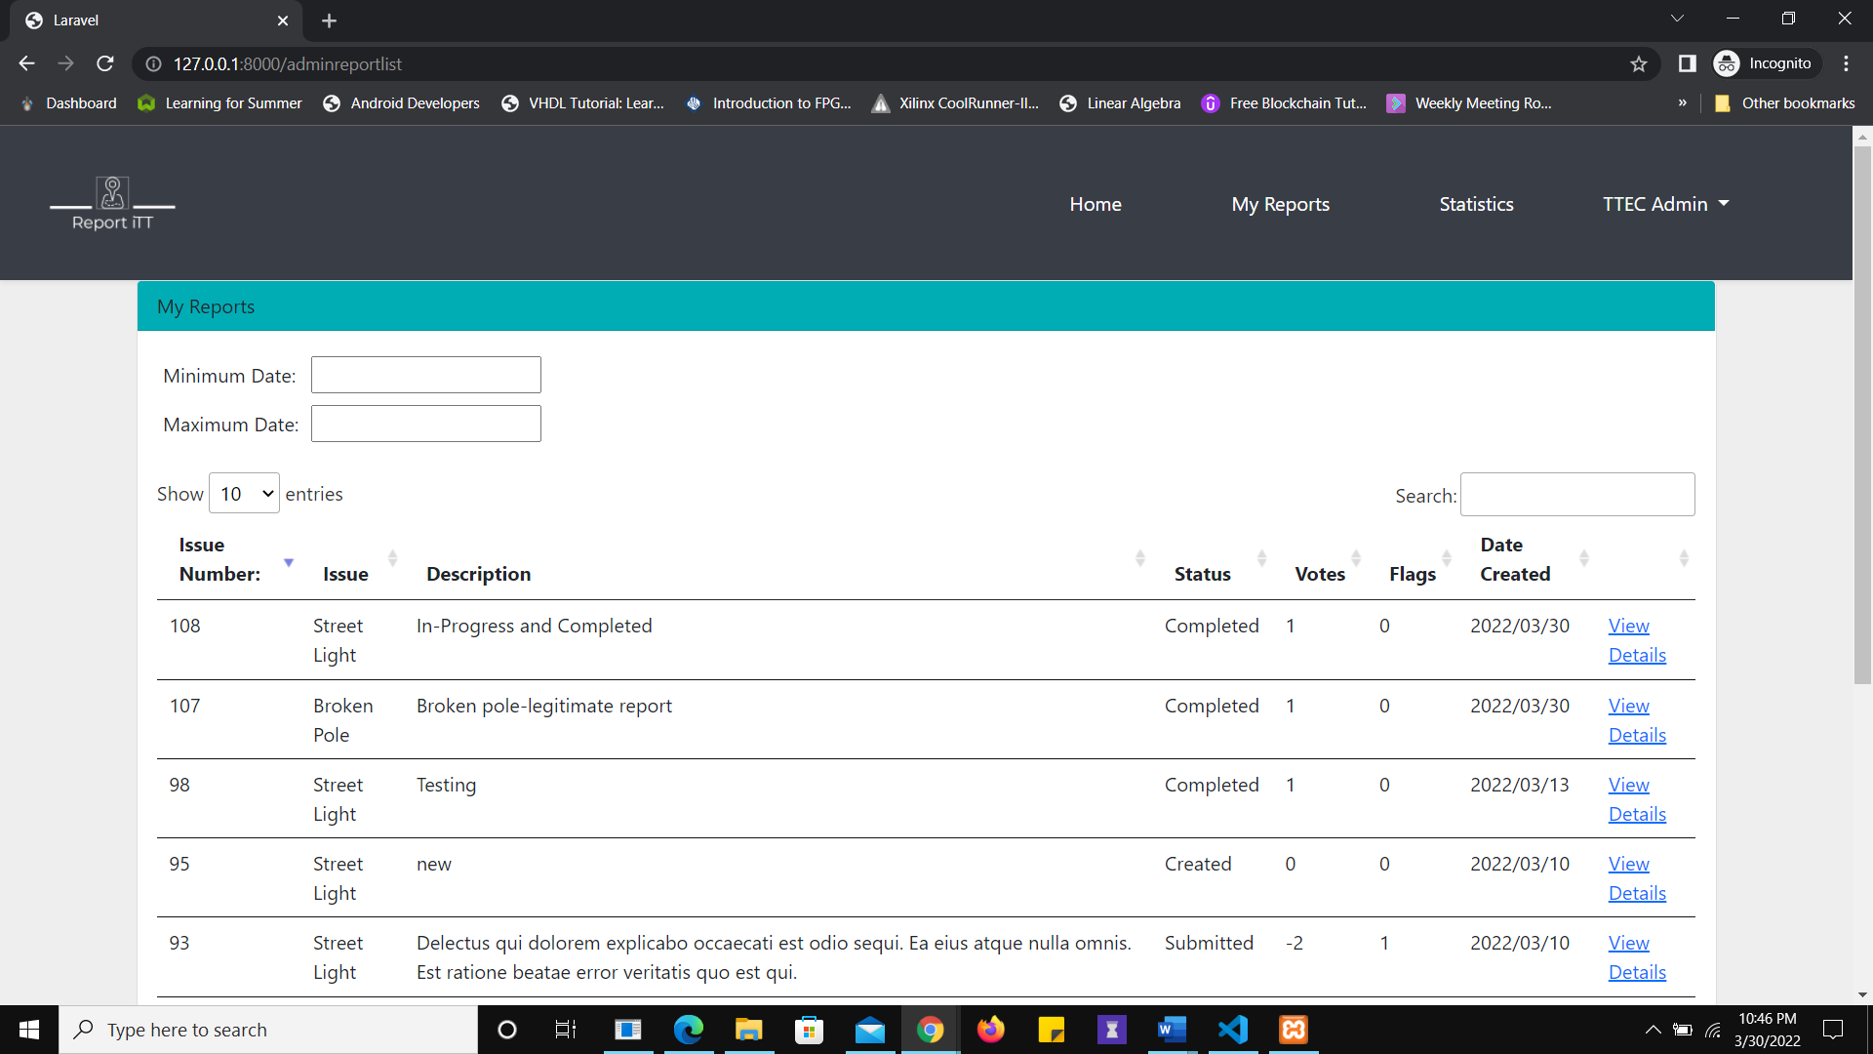

Figure 49 Only the faults reported to the same organization as the service provider is viewable in the "my reports" section

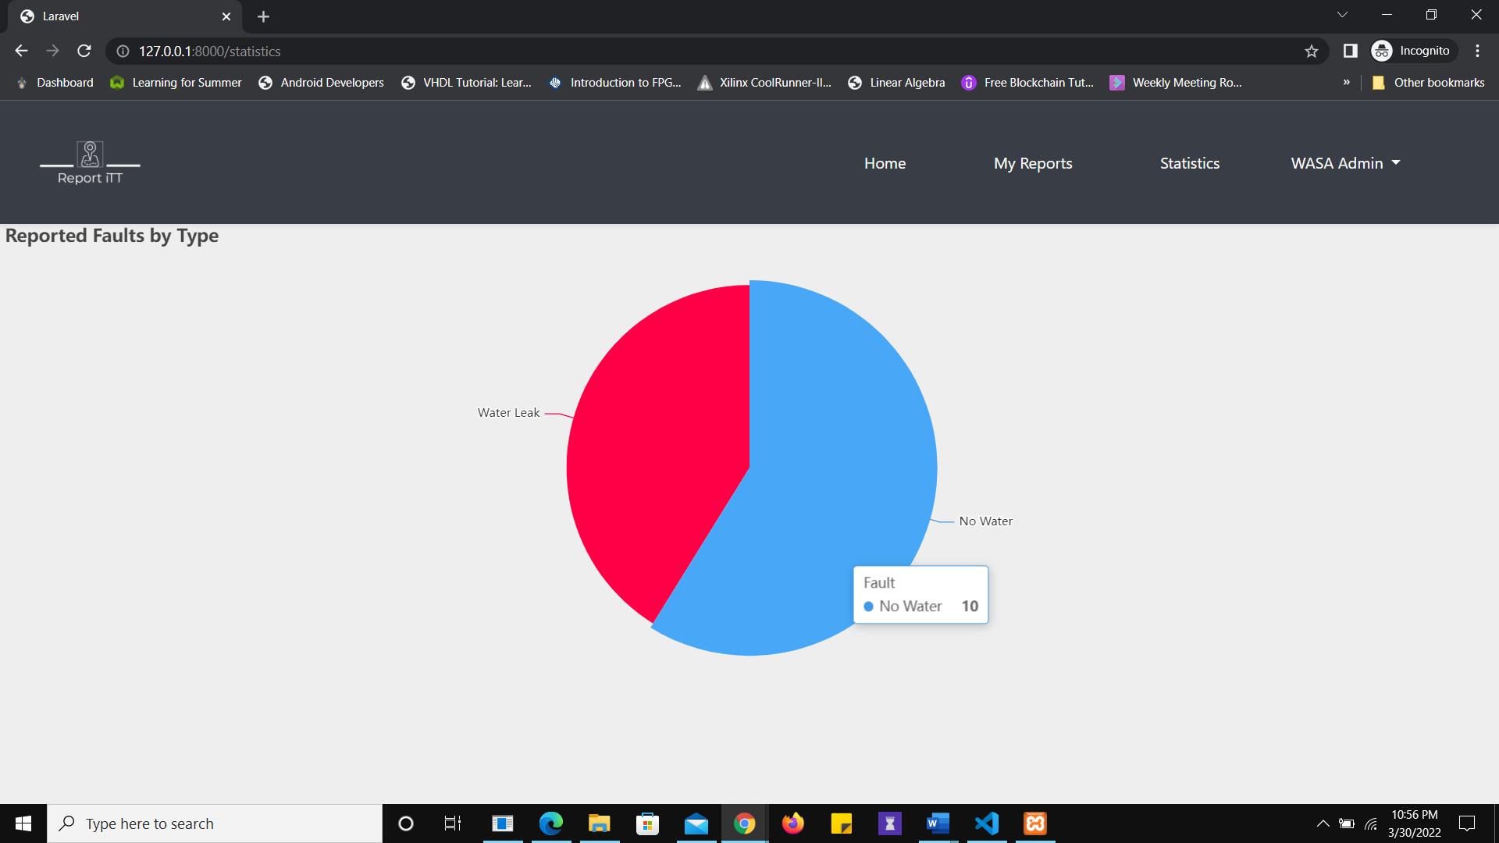

Figure 50 WASA Metrics are only seen by WASA SP-class users

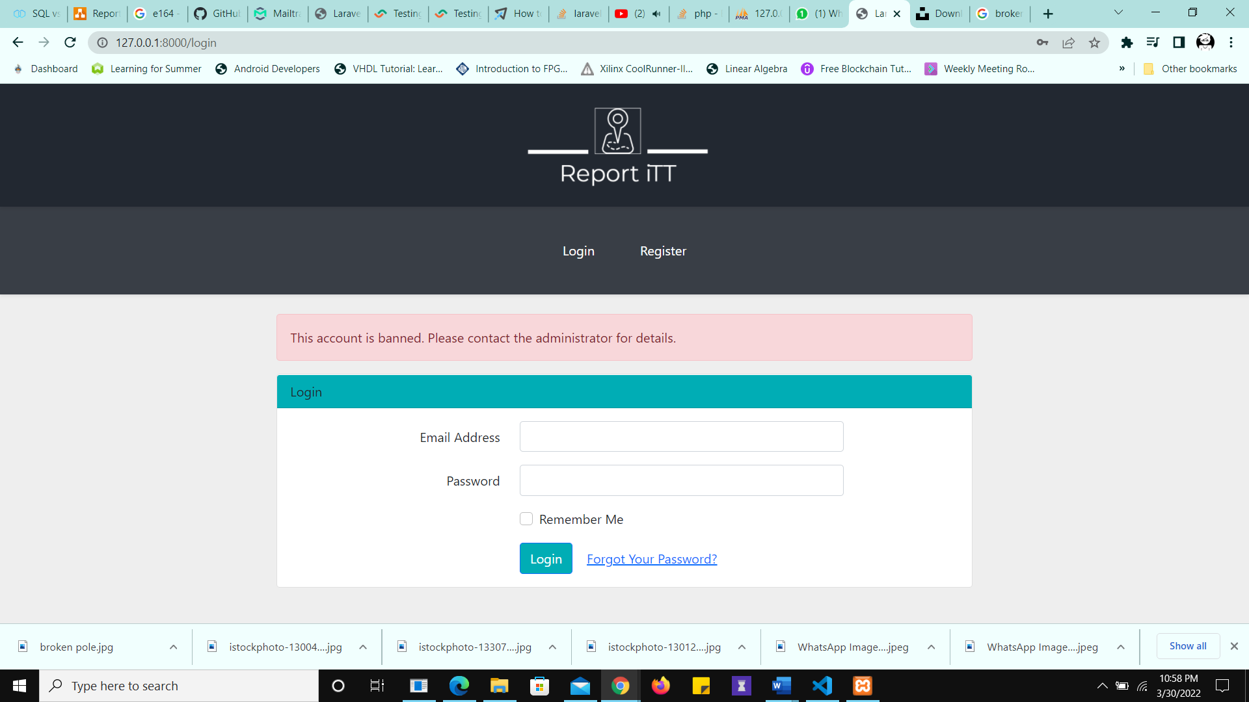

Figure 51 The user is Redirected to the Login portal if they are Banned.

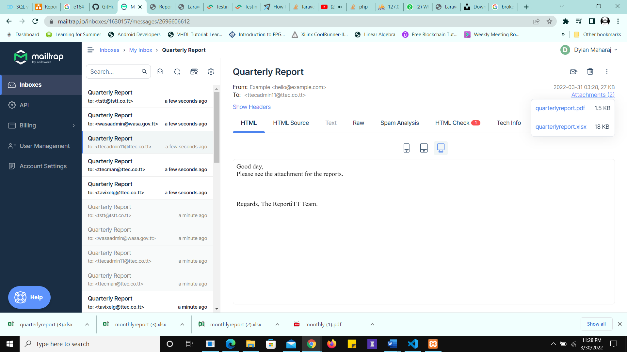

Figure 52 Export Received by Email with Attachments

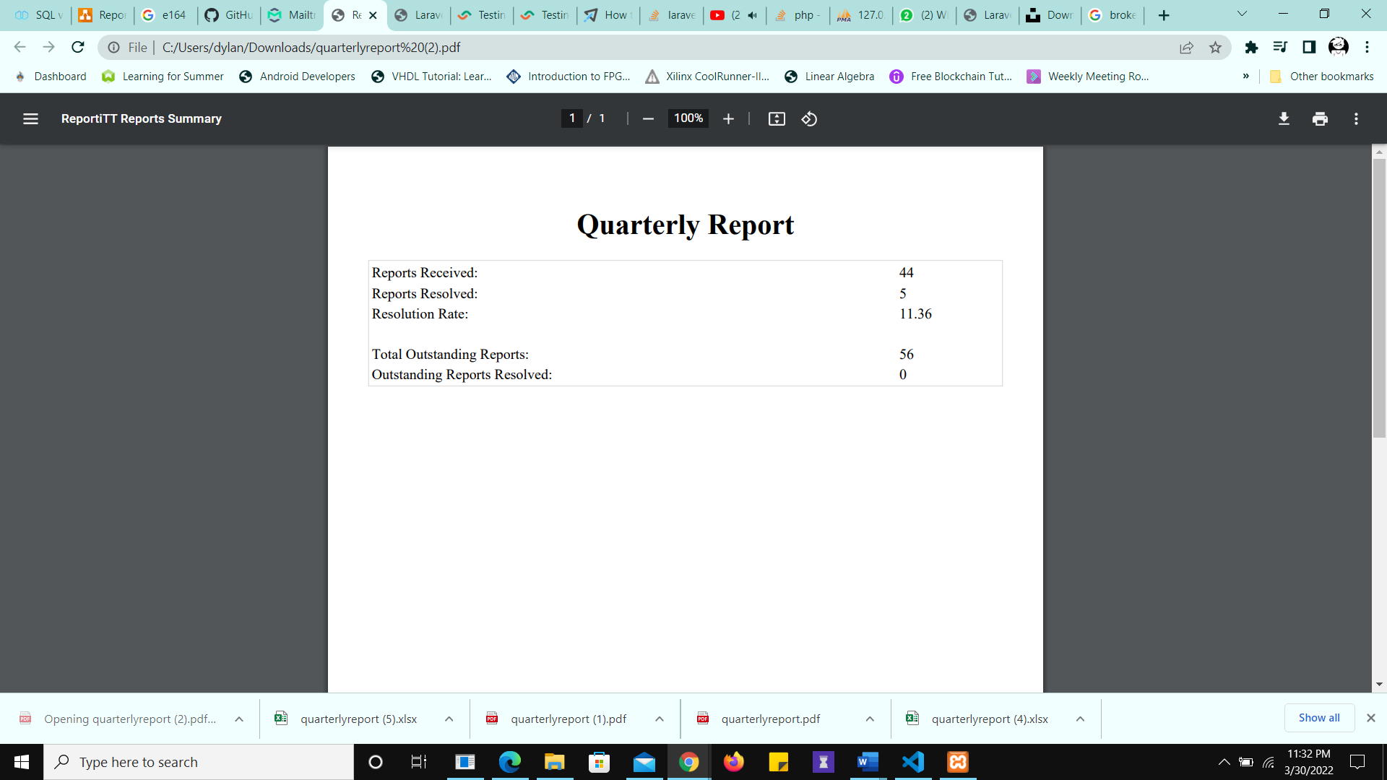

Figure 53 PDF Report Summary attachment (from email)

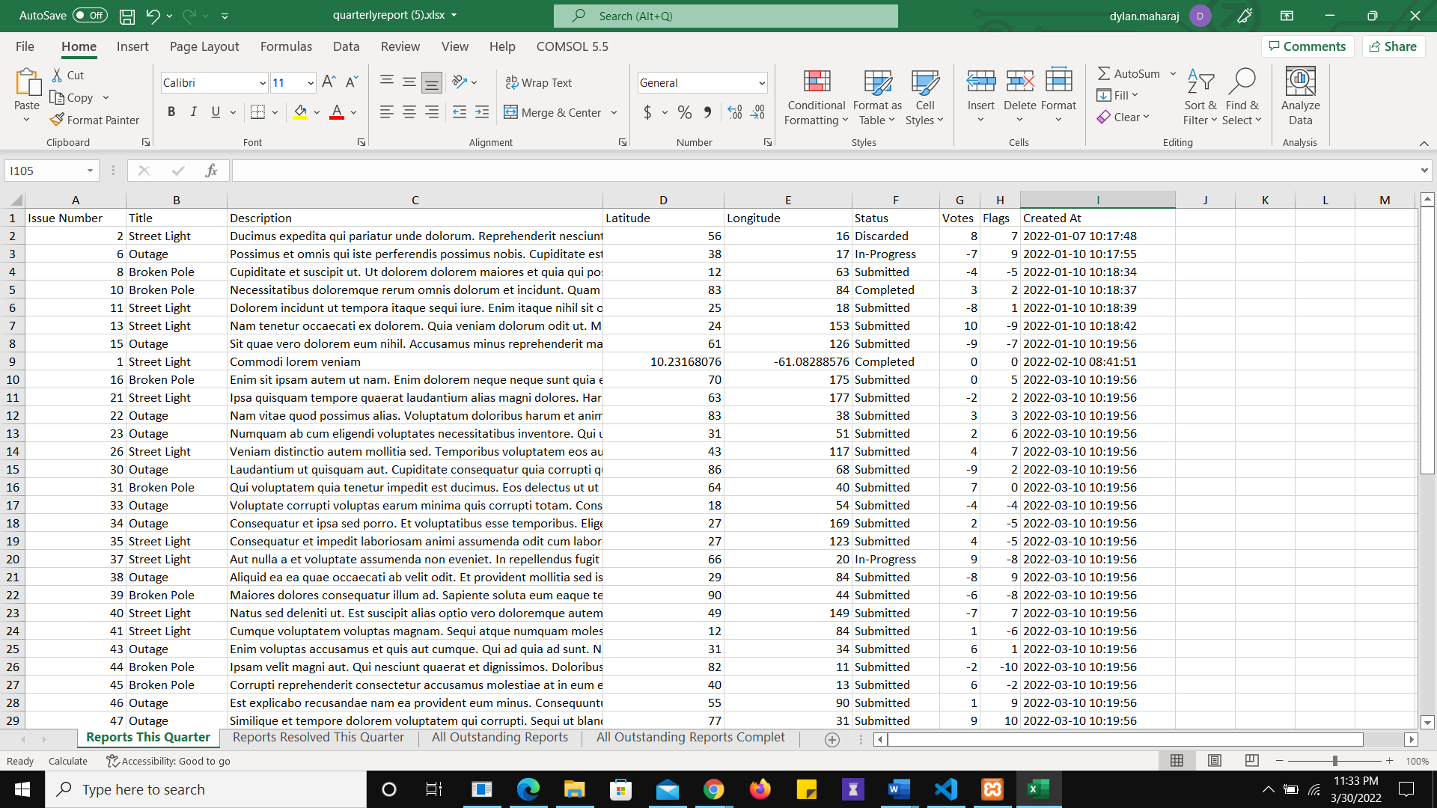

Figure 54 Reports Made this Quarter. Lorem Ipsum was used to generate the report description.

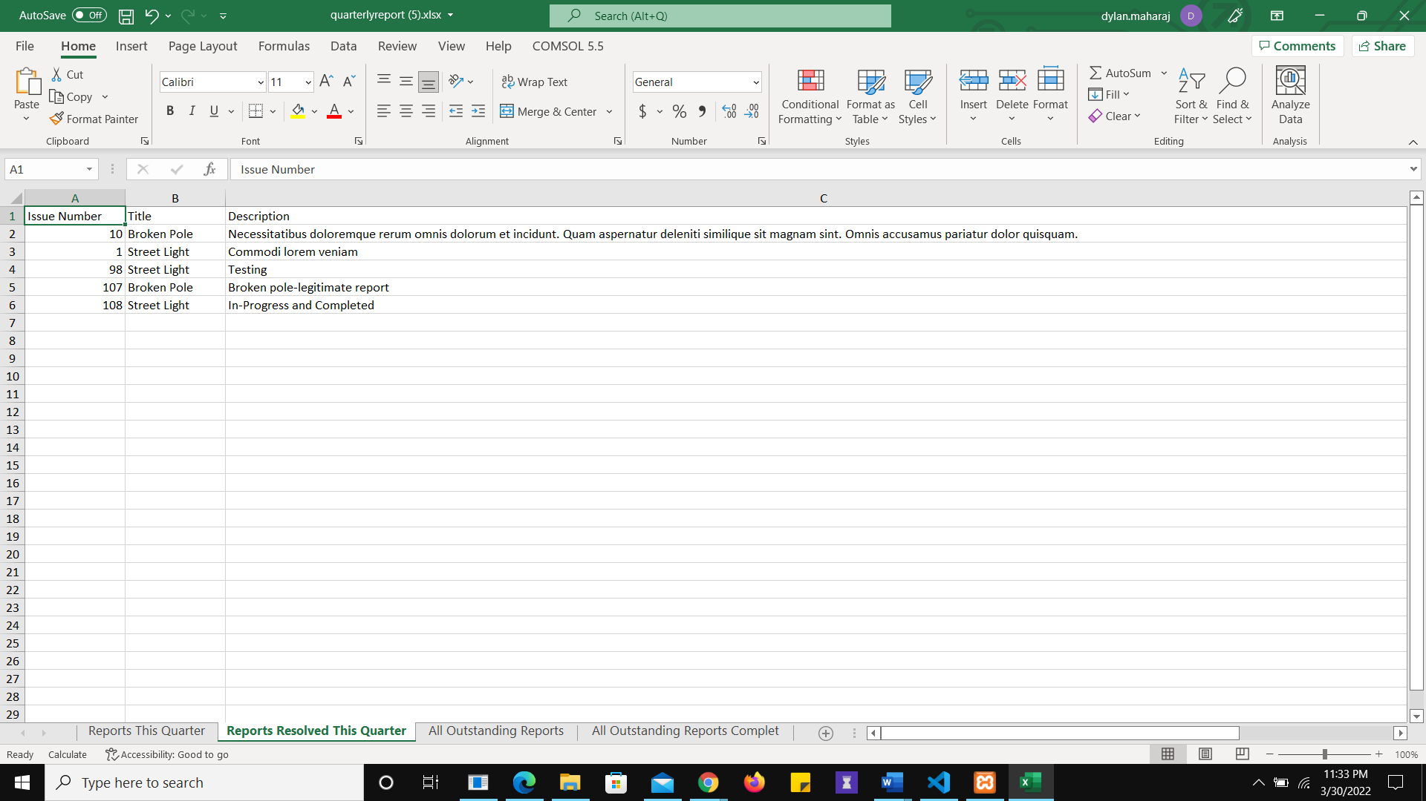

Figure 55 Reports Resolved this Quarter

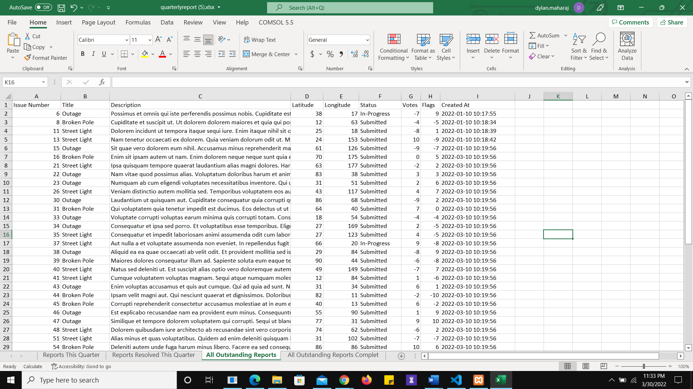

Figure 56 All Outstanding Reports (from period outside the quarter)

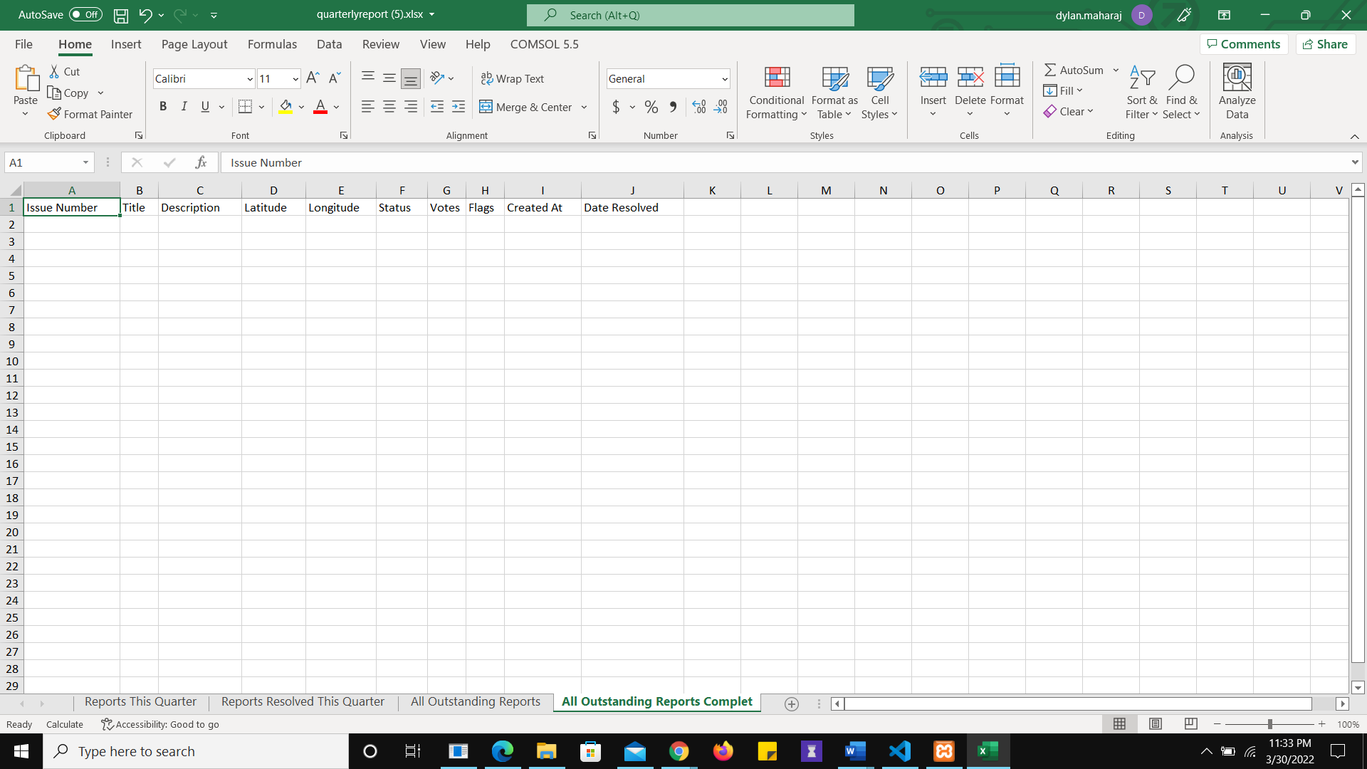

Figure 57 All outstanding reports resolved this quarter

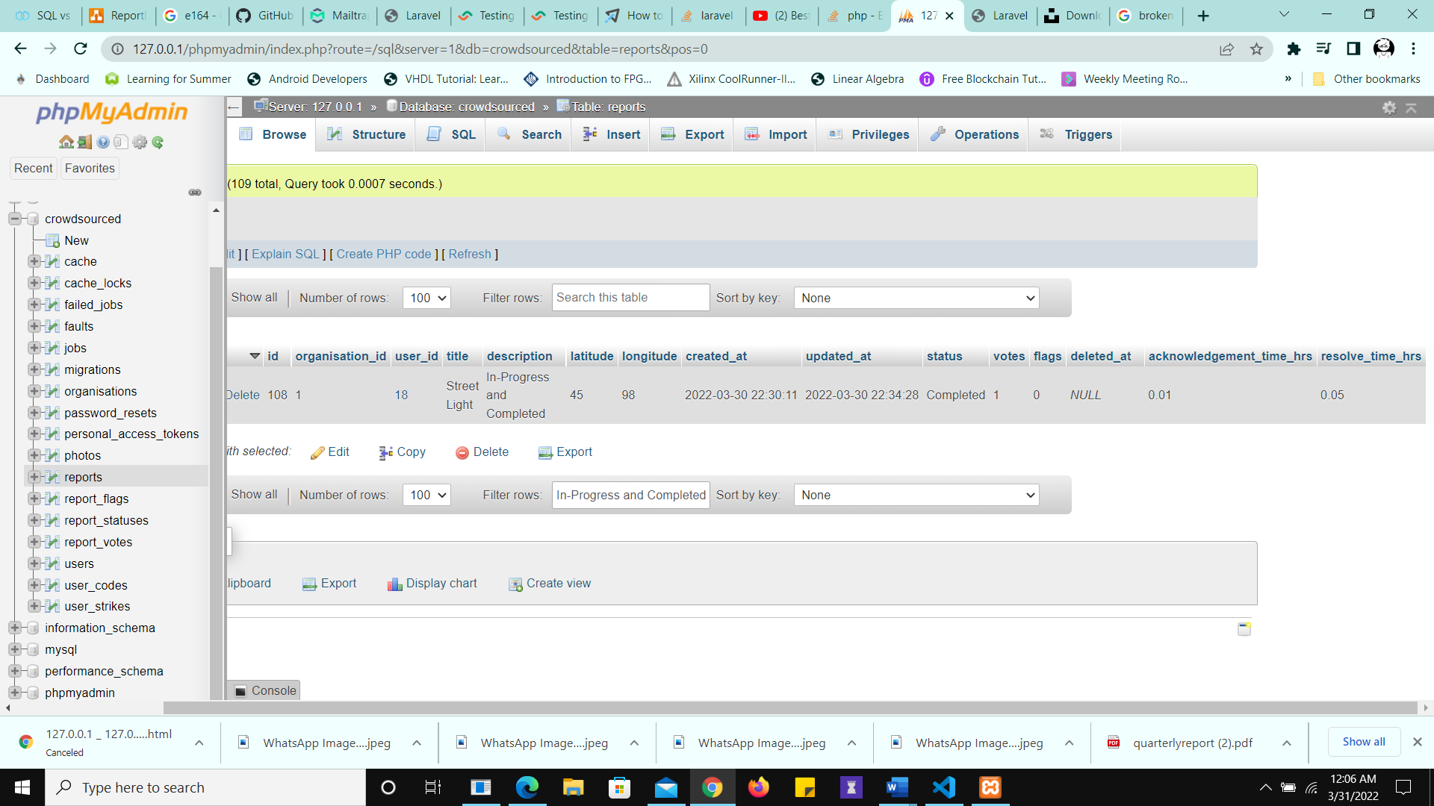

Figure 58 Metrics computed in hours